

Hendi Wibowo

Edisi 04 November 2019 (Draft)



**PANDUAN**

**DEVELOPER**

|  |  |
| --- | --- |
|  | *Panduan Pengembangan Aplikasi Perangkat Lunak dengan menggunakan framework CoreNET dan CoreNET Content Management System* |





**PANDUAN**

**DEVELOPER**

Hendi Wibowo

hendi135@gmail.com

Daftar Isi

Daftar Isi i

Bab 1. Instalasi ADK CoreNET Framework 1

1.1 Download ADK CoreNET Framework 1

1.2 Struktur Folder Published 1

1.3 Jalankan Launcher 2

1.4 Register CoreNET WebCMS 5

Bab 2 Inisialisasi Visual Studio Project Library 9

2.1 Struktur Project 10

2.2. Snippet 12

2.2.1. Klik Menu “Tools > Code Snippet Manager” 12

2.2.2. Pilih Language “C#” 12

2.2.3. Klik Tombol “Tambah”, lalu pilih folder “Tool\Snippet” di Folder CoreNET 13

2.2.4. Klik tombol “Select Folder” dan jika berhasil akan muncul halaman sbb. 13

2.3 Test Compile/Build Project 14

2.3.1. Klik kanan di “Project” lalu klik menu “Build” atau “Rebuild” 14

2.3.2. Klik kanan di “Project” lalu klik menu “Build Solution” atau “Rebuild Solution” 15

2.3.3. Klik Menu “Debug > Start without Debugging” 15

Bab 3 Tutorial 1 : Membuat dan Menambah Menu 16

3.1 Membuat BO (*Bussiness Object*) Class File 16

3.2 Meng-Compile/Build Project Library dan Setting File Konfigurasi 17

3.3 Menambahkan dan Mengkonfigurasi Menu 17

3.4 Menambahkan Mapping Menu di Modul Developer 18

3.5 Troubleshooting 18

Lampiran A CoreNET Framework – Class Diagram 19

A.1 CoreNET.Common.Lib 19

A.2 CoreNET.Common.Data 19

A.3 CoreNET.Common.UI 19

A.4 CoreNET.Common.Ext 20

Lampiran B CoreNET Framework – Documentation 21

B.1 CoreNET.Common.Lib 21

B.1.1 CoreNET.Common.Base 21

B.1.2 CoreNET.Common.BO 37

B.2 CoreNET.Common.Data 40

B.2.1 CoreNET.Common.Base 40

B.2.2 CoreNET.Common.BO 45

B.3 CoreNET.Common.UI 58

B.3.1 CoreNET.Common.Base 58

B.3.2 CoreNET.Common.BO 60

B.4 CoreNET.Common.Ext 60

B.3.1 CoreNET.Common.Base 60

B.3.2 CoreNET.Common.BO 62

B.5 CoreNET.Common.Sys 63

B.5.1 CoreNET.Common.Base 63

B.5.2 CoreNET.Common.BO 63

Lampiran C CoreNET Generator 68

1. Download CoreNET Generator Versi Terakhir 68

2. Connect ke Database 69

3. Generate BO (*Bussiness Object*) *Class* File 70

4. Generate *Lookup Class* File 70

5. Generate *Sibling Class* File 71

6. Generate XML File 71

7. Generate ConstantTables Entries 72

8. Generate sqlmap.config Entries 72

9. Generate Properties from Table 73

10. Generate ConstantTable Class 73

11. Generate Snippet Region IdataControlTreeGrid3 74

12. Generate Entries GetColumn() Method 74

13. Generate Entries GetEntries() Method 75

Lampiran D CoreNETLauncher 76

1. Jalankan CoreNETLauncher Versi Terakhir 76

2. Update WebCMS 76

3. Jalankan CoreNETLauncher Versi Terakhir 76

Lampiran E Instalasi WebCMS di Internet Information Services (IIS) 77

Lampiran F Data Berstruktur/Berlevel/Berjenjang 78

Lampiran G Status dan Status Icon 78

Lampiran H Daftar Jenis ParameterRow (Entry di GetEntries) 78

Lampiran I Daftar Jenis Kolom Grid (Entry di GetColumn) 79

# Bab 1. Instalasi ADK CoreNET Framework

## 1.1 Download ADK CoreNET Framework

Kunjungi portal <https://corenet.usadi.id>, dan klik “**Download CoreNET**”.

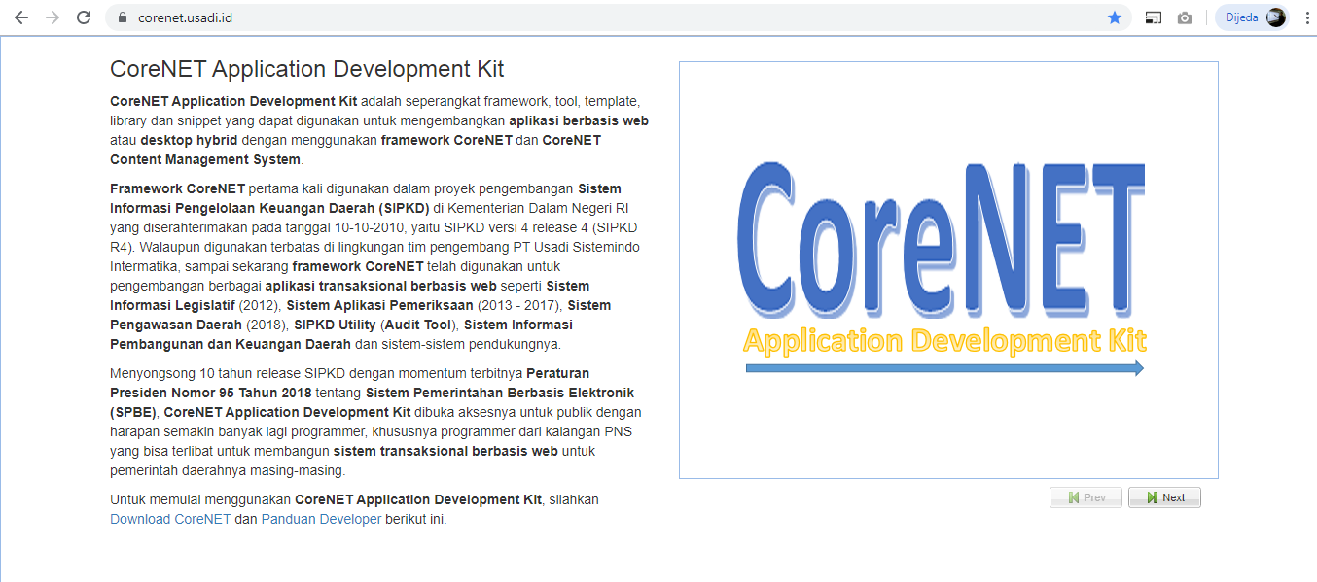

Atau anda bisa men-download CoreNET ADK dari link *github* berikut ini:

<https://github.com/hw22011980/CoreNET/>

Extract ke drive “D:\” dan bukalah folder **\Published**, sebagaimana gambar berikut ini:

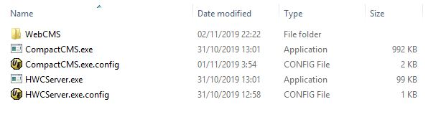

**Catatan :** Pastikan setting di ***windows explorer*** menampilkan ekstensi file, agar terlihat jelas perbedaan file “**\*.exe**” dan file “**\*.exe.config**”

## 1.2 Struktur Folder Published

Folder **Published** terdiri dari beberapa file, diantaranya file-file berikut ini:

| No | Nama Folder/File | Keterangan |
| --- | --- | --- |
| 1 | WebCMS | Folder aplikasi CMS berbasis web menggunakan ASP.NET dan .NET Framework |
| 2 | CoreNETLauncher.exe | *Launcher* dari CMS, aplikasi desktop yang mengandung *embedded internet browser* |
| 3 | CoreNETLauncher.exe.config | Berisi konfigurasi dariaplikasi***CoreNETLauncher.exe*** |
| 4 | HWCServer.exe | Aplikasi *embedded web server*, sebagai alternatif pengganti IIS |
| 5 | HWCServer.exe.config | Berisi konfigurasi dariaplikasi***HWCServer.exe*** |

## 1.3 Jalankan Launcher

1. Klik file **CoreNETLauncher.exe** sehingga menampilkan tampilan sbb. (Pastikan aplikasi dikecualikan dari aplikasi anti virus di komputer anda).

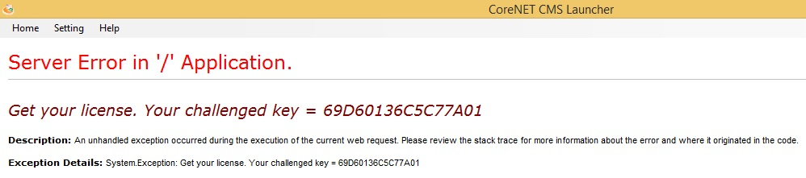

1. Jika halaman “***Get your license***” yang muncul, aplikasi **WebCMS** sudah berhasil terinstal di komputer anda, dengan alamat sesuai dengan yang ada di file **CoreNETLauncher.exe.config**, yaitu di **localhost** dan default port **54321** sbb. (setting port yang *compatible* dapat diubah selama port tersedia)
2. Jika muncul **error 404**, “*the resource cannot be found*” seperti ini, **WebCMS** belum terinstal dengan benar, karena (1) **embeded webserver** belum berhasil *running* atau (2)setting URL tidak valid.

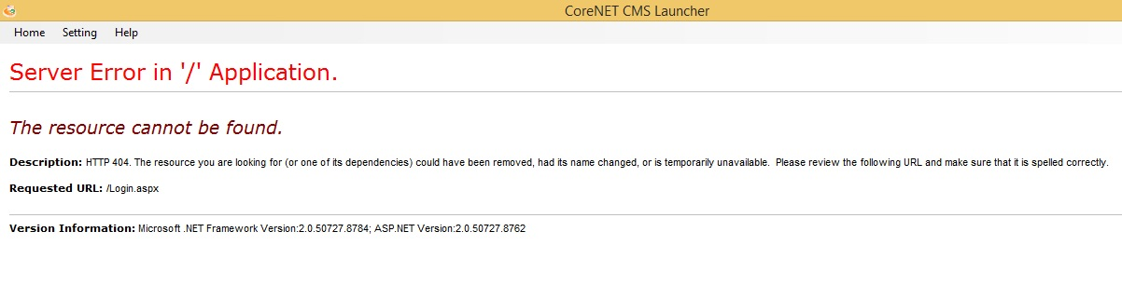

1. Bukalah file konfigurasi **CoreNETLauncher** dengan mengklik menu “Launcher config”, lalu buka dengan menggunakan **notepad** atau **text editor** lainnya sbb.

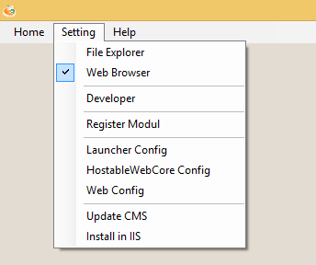

1. Perhatikan sebagian isi file konfigurasi **CoreNETLauncher** berikut ini.

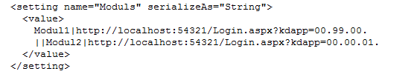

Modul/aplikasi yang tersedia, sesuai nilai *Value* dari *setting name* “**Moduls**” pada contoh di atas adalah sbb.

|  |  |  |
| --- | --- | --- |
| No | Judul | URL |
| 1 | Modul1 | http://localhost:54321/Login.aspx?kdapp=00.99.00. |
| 2 | Modul2 | http://localhost:54321/Login.aspx?kdapp=00.00.01. |

Perhatikan delimiter (karakater pembatas) untuk pemisah modul adalah “||”, sedangkan untuk pemisah judul modul dengan URLnya adalah “|”;

1. Jika yang muncul **error 404**, “*the resource cannot be found*” seperti point 3. Artinya URL aplikasi sebagaimana terdaftar di **konfigurasi Launcher** tidak bisa diakses (URL tidak ditemukan).

Solusi yang dapat dilakukan adalah (1) *troubleshooting* aplikasi **HWCServer.exe** (*HostableWebCore Server*), yaitu aplikasi yang berfungsi sebagai web server sebagai pengganti IIS, (2) Instal aplikasi CMS di IIS.

Pada tutorial ini, akan ditunjukkan bagaimana melakukan instalasi/registrasi aplikasi CoreNET CMS di aplikasi IIS.

1. Klik menu “**Install in IIS**” seperti pada gambar berikut ini.



Lalu akan muncul halaman seperti gambar berikut ini.

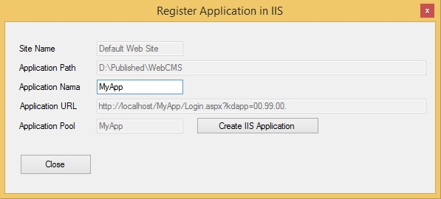

Isikan “**Application Name**” lalu tekan tombol “**Create IIS Application**”. Lalu tutup jendela dengan mengklik tombol “**Close**”;

1. Setelah anda berhasil menambah aplikasi **WebCMS** di IIS, cobalah akses URL yang dibentuk dengan menggunakan **internet browser**. Lakukan “Paste” pada halaman URL. Setelah berhasil, sesuaikan url yang dibuat pada file **konfigurasi launcher** seperti **langkah 3**.

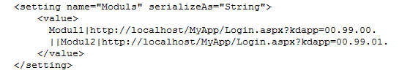

1. Tutup aplikasi lalu buka kembali untuk menampilkan perubahan yang sudah dilakukan
2. Jika diperlukan anda dapat melakukan instalasi manual aplikasi **WebCMS** di IIS dengan menggunakan **IIS Manager**
3. Jika masih ada masalah, kirimkan deskripsi permasalahan, disertai capture layar komputer jika diperlukan, melalui email ke [corenet.admin@gmail.com](mailto:corenet.admin@gmail.com)

## 1.4 Register CoreNET WebCMS

1. Klik menu “**Register Modul**” seperti pada gambar berikut ini



1. Masukkan alamat email, nomor ponsel, password dan ulangi password. Lalu klik tombol “**Register**”.

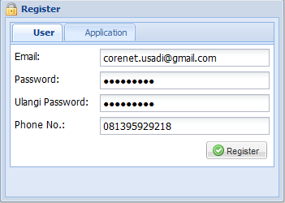

1. Setelah itu masuklah ke **Modul Developer** dengan mengklik menu “**Developer**”



1. Masukkan login dengan email dan password yang sudah ditambahkan di **langkah 2**

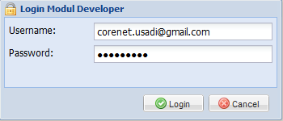

1. Klik menu “Lisensi” seperti di gambar berikut ini

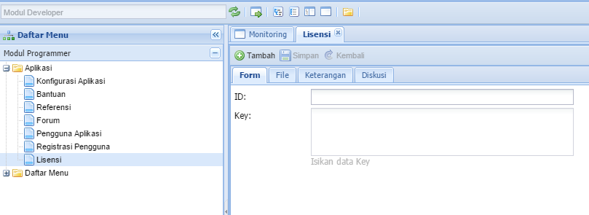

1. Klilk tombol “**Tambah**” lalu copaskan “**challenge key**” yang diperoleh dari langkah 1.3. di field ID seperti gambar berikut ini.

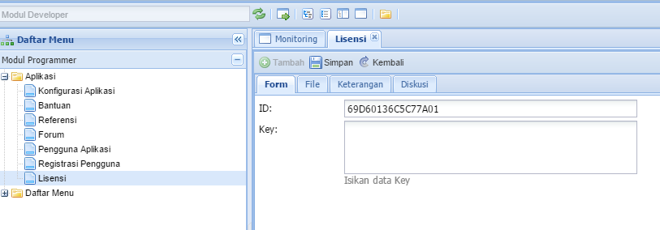

1. Klik tombol”**Simpan**”, lalu copykan isi nilai “**Key**”

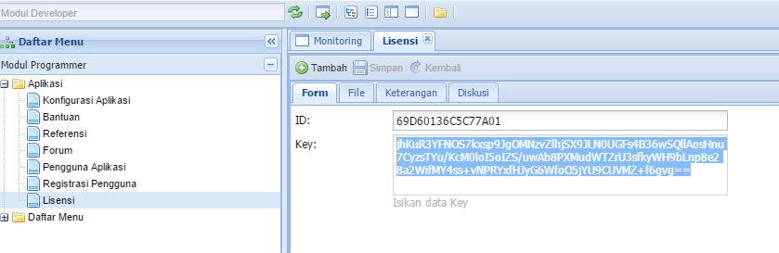

1. Klik menu “**Web Config**”



1. Paste kan nilai “**Key**” di langkah 7 ke baris di file “**web.config**” sbb.

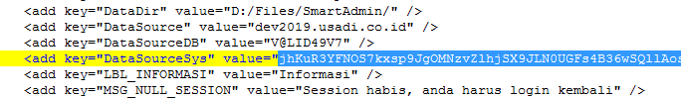

1. Tutup aplikasi lalu buka kembali untuk menampilkan perubahan yang sudah dilakukan
2. Akan tampil halaman login ke modul aplikasi “**Panduan Developer**”

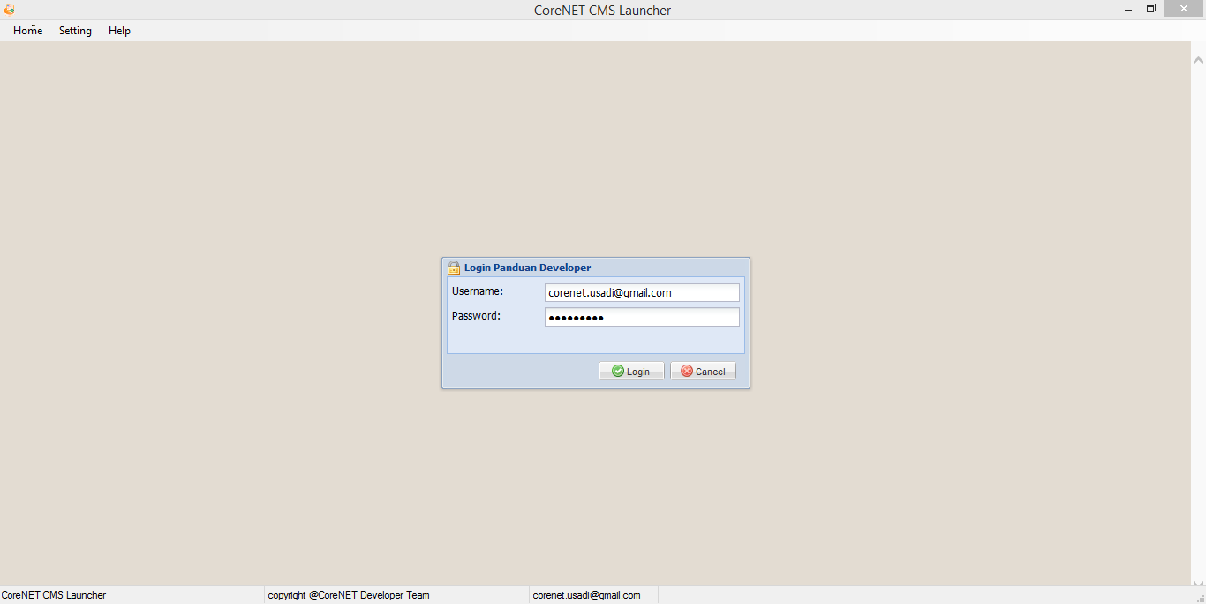

1. Jika masih ada masalah, kirimkan deskripsi permasalahan, disertai capture layar komputer jika diperlukan, melalui email ke [corenet.usadi@gmail.com](mailto:corenet.usadi@gmail.com)

# Bab 2 Inisialisasi Visual Studio Project Library

1. Setelah anda men-download ADK CoreNET Framework dari <https://github.com/hw22011980/CoreNET/>, extract dan bukalah folder \Resources, sebagaimana gambar berikut ini:

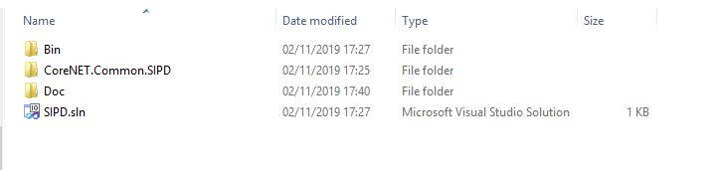

|  |  |  |
| --- | --- | --- |
| No | Nama Folder/File | Keterangan |
| 1 | Bin | Berisi file binary (*.dll) CoreNET dan *dependent library* eksternal lainnya |
| 2 | CoreNET.Common.SIPD | Berisi *source code project library* |
| 3 | Doc | Berisi file ini dan dokumentasi lainnya |
| 4 | SIPD.sln | Microsoft Visual Studio Solution |

1. Jika anda sudah menginstal **Visual Studio 2010** (atau versi yang lebih baru), klik dua kali file SIPD.sln sehingga muncul gambar berikut ini:

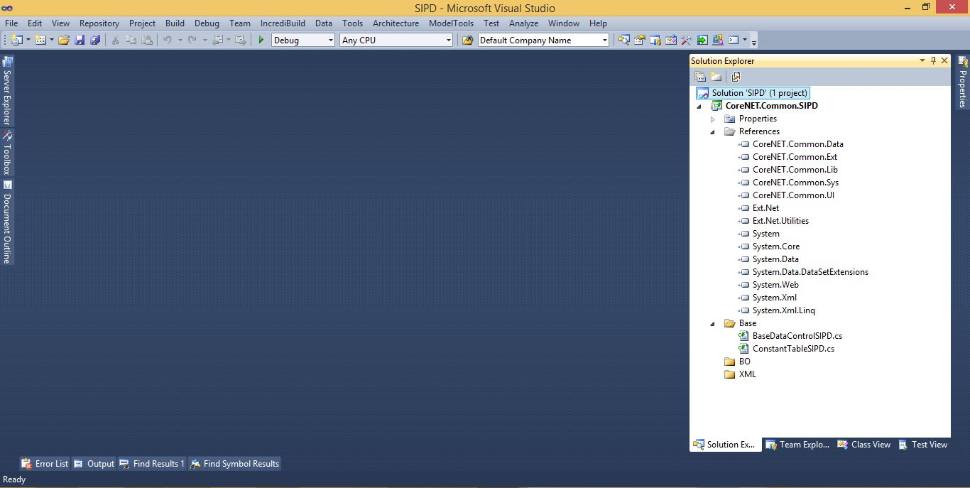

Perhatikan jendela *Solution Explorer*, berikut ini:

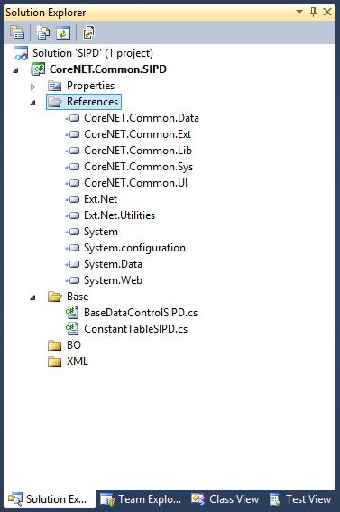

## 2.1 Struktur Project

Template *project library* CoreNET terdiri dari beberapa *artefact* utama, sbb:

| No | Nama Folder/File | Keterangan |
| --- | --- | --- |
| 1 | Properties | Berisi *properties* dan *assembly information* dari *project* |
| 2 | References | Berisi file *binary* (*.dll) CoreNET dan *dependent library* eksternal lainnya |
|  | CoreNET.Common.Data | Berisi *library* untuk akses data menggunakan ibatis.NET dan BO *class system* |
|  | CoreNET.Common.Ext | Berisi *base* *class, interface dan utilities* untuk mapping *controller* (BO *class)* dengan UI komponen Ext.NET |
|  | CoreNET.Common.Lib | *Library* berisi *base* *class, interface dan utilities* dasar framework CoreNET |
|  | CoreNET.Common.Sys | Berisi BO *class system* yang digunakan pada modul developer dan dapat di-*inherit*, jika diperlukan |
|  | CoreNET.Common.UI | Berisi *base* *class, interface dan utilities* untuk mapping *controller* (BO *class)* dengan UI komponen ASP.NET |
|  | Ext.Net | Library untuk komponen UI Ext.NET |
|  | Ext.Net.Utilities | Library untuk utility Ext.NET |
|  | System | Library .NET Framework standar |
|  | System.configuration | Library .NET Framework untuk mengelola konfigurasi yang disimpan di file *.config |
|  | System.Data | Library .NET Framework berisi *utilities* untuk mengelola data |
|  | System.Web | Library untuk komponen UI Ext.NET |
| 3 | Base | Berisi *source code* yang menjadi *base class* atau banyak digunakan di *class-class* lainnya |
|  | BaseDataControlSIPD.cs | Base class untuk semua BO (*bussiness object*) *class* |
|  | ConstantTableSIPD.cs | Class untuk menyimpan konstanta yang sering digunakan, khususnya kontantan untuk nama file XML yang akan diset pada property XMLName |
| 4 | BO | Folder tempat menyimpan *source code* BO (*bussiness object*) *class* |
| 5 | XML | Folder tempat menyimpan file XML berisi query ke database |

## 2.2. Snippet

Tambahkan Code Snippets di Visual Studio 2010 dengan cara sbb.

### 2.2.1. Klik Menu “Tools > Code Snippet Manager”

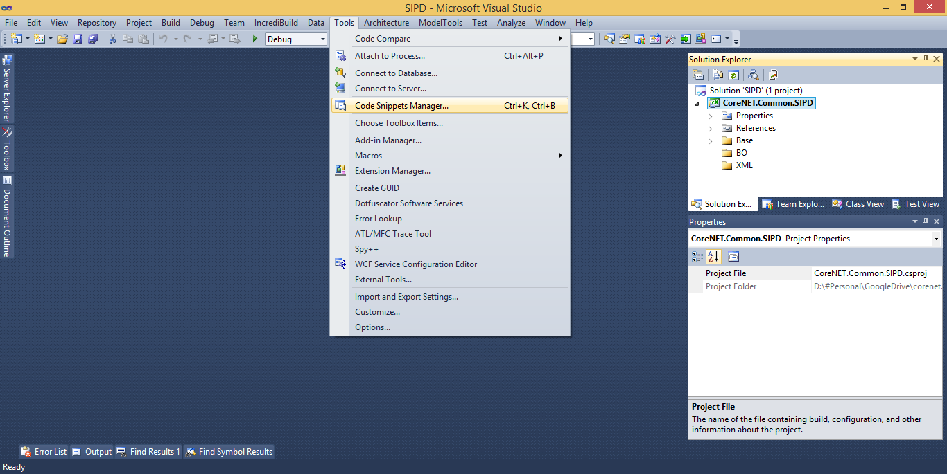

### 2.2.2. Pilih Language “C#”

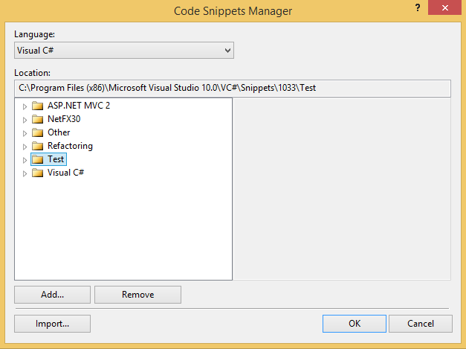

### 2.2.3. Klik Tombol “Tambah”, lalu pilih folder “Tool\Snippet” di Folder CoreNET

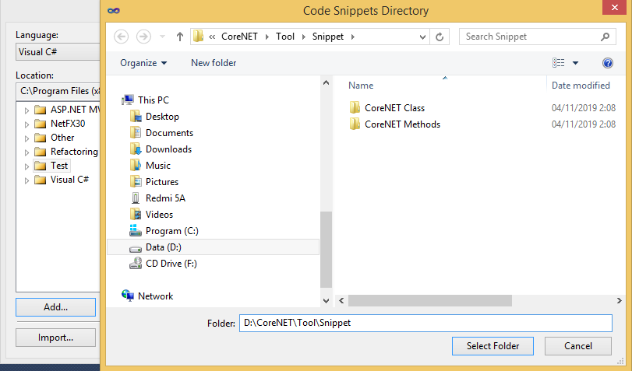

### 2.2.4. Klik tombol “Select Folder” dan jika berhasil akan muncul halaman sbb.

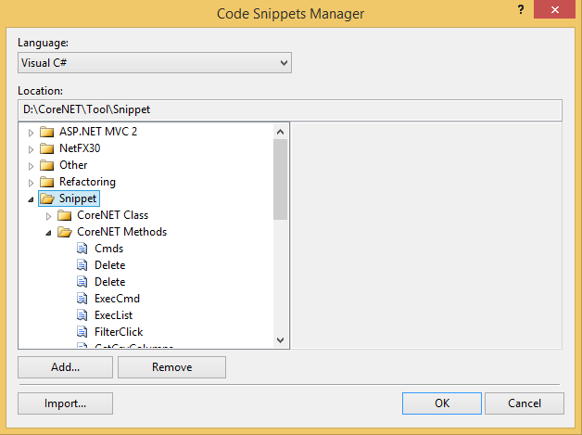

## 2.3 Test Compile/Build Project

### 2.3.1. Klik kanan di “Project” lalu klik menu “Build” atau “Rebuild”

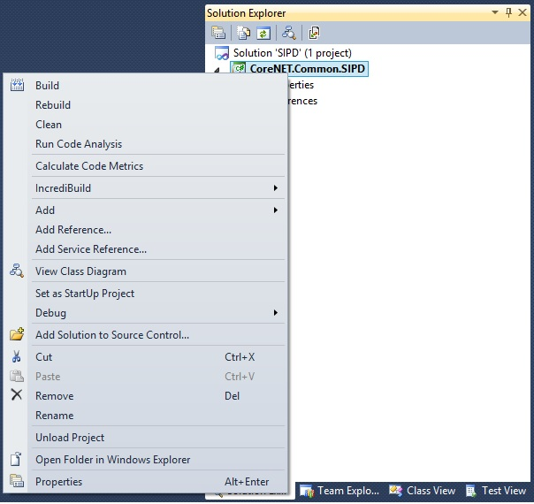

### 2.3.2. Klik kanan di “Project” lalu klik menu “Build Solution” atau “Rebuild Solution”

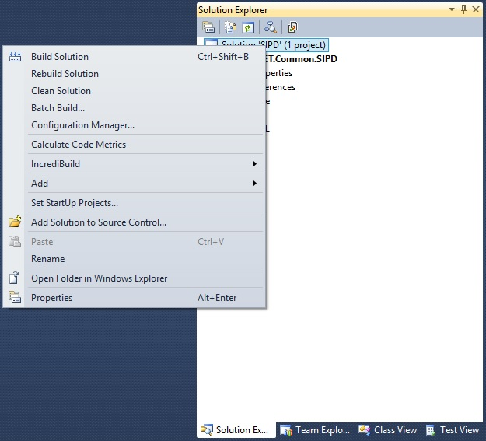

### 2.3.3. Klik Menu “Debug > Start without Debugging”

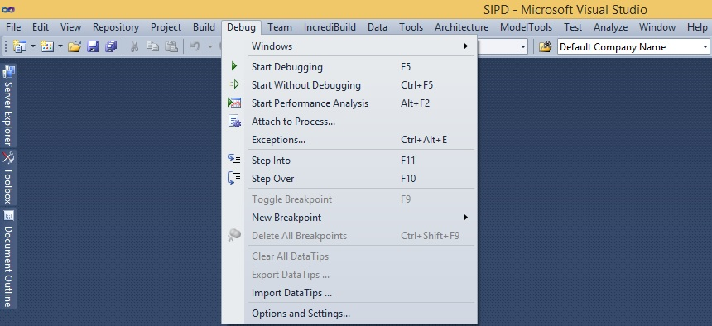

# Bab 3 Tutorial 1 : Membuat dan Menambah Menu

Untuk membuat dan menambah menu, lakukan langkah – langkah berikut ini:

## 3.1 Membuat BO (*Bussiness Object*) Class File

1. Jalankan *tool* **CoreNET Generator** (lihat lampiran C)
2. *Generate* BO (*Bussiness Object*) *Class File* dari tabel “**DWAPBD**”

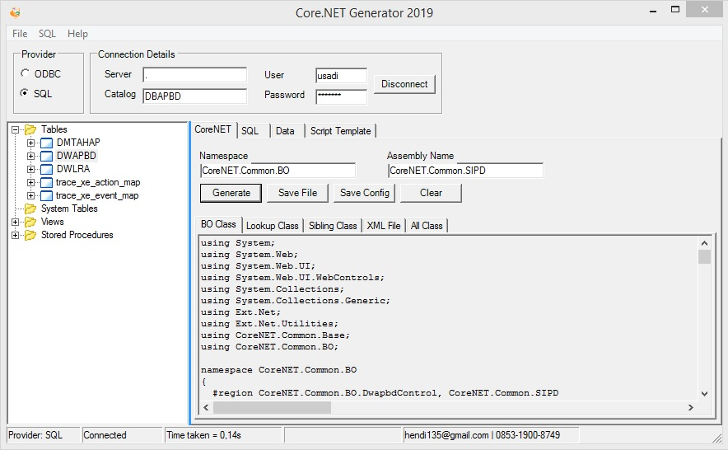

1. Simpan File “**Dwapbd.cs**” ke folder “**CoreNET.Common.SIPD\BO**"

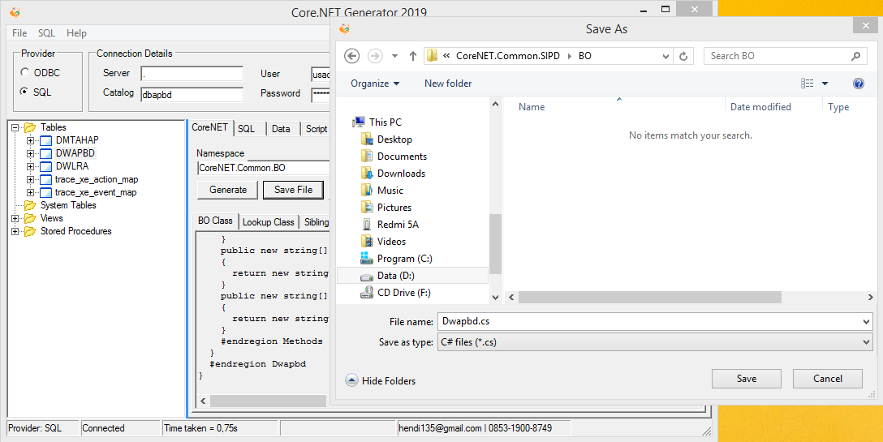

1. Simpan File “**Dwapbd.xml**” ke folder “**CoreNET.Common.SIPD\XML**"

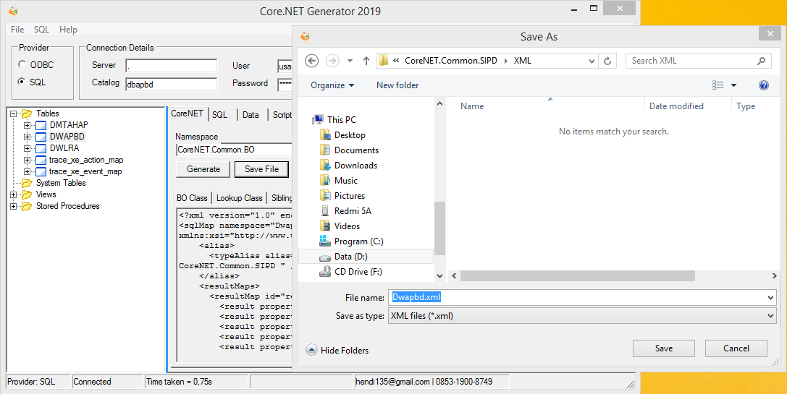

1. Kli tombol “**Show All Files**” untuk menampilkan file “**Dwapbd.cs**” dan “**Dwapbd.xml**” yang baru dibuat
2. Tambahkan file “**Dwapbd.cs”** dan “**Dwapbd.xml**” ke dalam project dengan cara mengklik kedua file, klik kanan lalu pilih menu “**Include** ”
3. Untuk semua file XML, pilih file XML, klik kanan pilih menu Properties untuk menampilkan jendela “Properties”. Lalu ubah nilai “Build Action” menjadi “Embedded Resource”

## 3.2 Meng-Compile/Build Project Library dan Setting File Konfigurasi

1. Pilih mode pada Configuration Manager, apakah mode “**Debug**” atau “**Release**”
2. Build/rebuild project menjadi file library “**CoreNET.Common.SIPD.dll**”
3. Jika mode “Debug”, file dll akan terbentuk di folder “bin/Debug”. Jika mode “release”, file dll akan terbentuk di folder “bin/Release”
4. Copykan file dll ke folder “WebCMS/bin” yang ada di folder “published” dari folder CoreNET
5. Tambahkan register semua file XML yang telah menjadi embedded resource di file “**CoreNET.Common.SIPD.dll**”

## 3.3 Menambahkan dan Mengkonfigurasi Menu

1. Masuklah ke **Modul Developer** dengan mengklik menu “**Developer**”



1. Buka Menu Register Menu. Klik tombol “Tambah” untuk menambah struktur menu
2. dsfdsf

## 3.4 Menambahkan Mapping Menu di Modul Developer

## 3.5 Troubleshooting

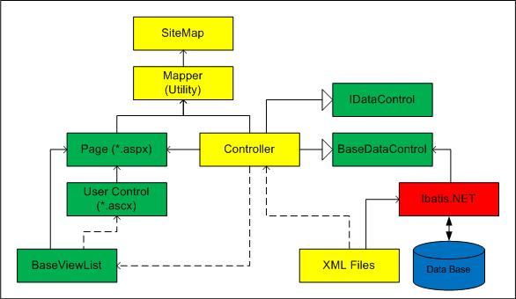

# Lampiran A CoreNET Framework – Class Diagram

## A.1 CoreNET.Common.Lib

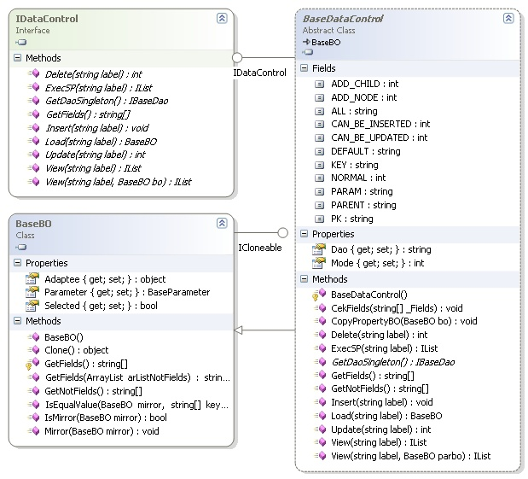

## A.2 CoreNET.Common.Data

## A.3 CoreNET.Common.UI

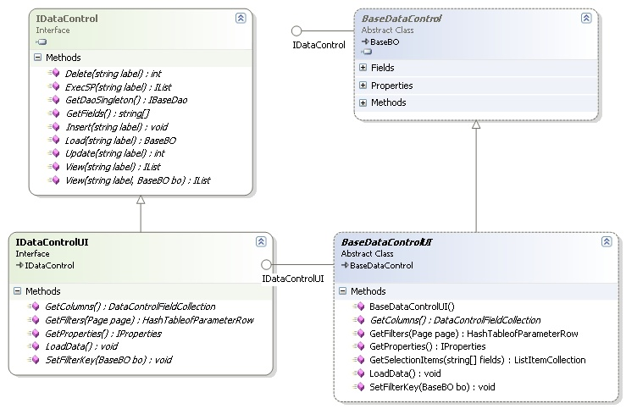

## A.4 CoreNET.Common.Ext

# Lampiran B CoreNET Framework – Documentation

## B.1 CoreNET.Common.Lib

### B.1.1 CoreNET.Common.Base

|  |  |  |  |
| --- | --- | --- | --- |
| No | Type | Nama | Keterangan |
| 1 | Class | BaseBO |  |
| 2 | Class | BaseDataAdapter |  |
| 3 | Class | GlobalData |  |
| 4 | Class | GlobalLib |  |
| 5 | Class | MasterAppConstants |  |
| 6 | Class | MyDocumentFormat |  |
| 7 | Class | SoftwareBit2 |  |
| 8 | Class | SQLDataSource |  |
| 9 | Class | UtilityBO |  |
| 10 | Class | UtilityLib |  |
| 11 | Interface | ICsv |  |
| 12 | Interface | IDashboard |  |
| 13 | Interface | IDataControl |  |
| 14 | Interface | IDataControlApp |  |
| 15 | Interface | IDataControlAppuser |  |
| 16 | Interface | IDataControlDictionary |  |
| 17 | Interface | IDataControlMenuMapClass |  |
| 18 | Interface | IDataControlText |  |
| 19 | Interface | ILoadCsv |  |
| 20 | Interface | ITable |  |

#### B.1.1.1 BaseBO

|  |  |  |  |
| --- | --- | --- | --- |
| **No** | **Type** | **Nama** | **Ket** |
| 1 | Method | BaseBO() |  |
| 2 | Method | CekFields(string[]) |  |
| 3 | Method | ChangeModePreviewIndex() |  |
| 4 | Method | Clone(CoreNET.Common.Base.IDataControl) |  |
| 5 | Method | Clone1() |  |
| 6 | Method | Clone2<BaseBO>(BaseBO) |  |
| 7 | Method | CopyPropertyBO(CoreNET.Common.Base.BaseBO) |  |
| 8 | Method | CopyPropertyBOFrom(CoreNET.Common.Base.BaseBO) |  |
| 9 | Method | CopyPropertyBOFrom(CoreNET.Common.Base.BaseBO, string[]) |  |
| 10 | Method | Create(string) |  |
| 11 | Method | GetFields() |  |
| 12 | Method | GetFields(System.Collections.ArrayList) |  |
| 13 | Method | GetFieldsString() |  |
| 14 | Method | GetMaxModePreviewIndex() |  |
| 15 | Method | GetModePreviewIndex() |  |
| 16 | Method | GetNotFields() |  |
| 17 | Method | GetProgressicon(decimal) |  |
| 18 | Method | GetProperty(string) |  |
| 19 | Method | GetStaticDefaultDebug(CoreNET.Common.Base.BaseBO) |  |
| 20 | Method | GetValue(string) |  |
| 21 | Method | IsEqualValue(CoreNET.Common.Base.BaseBO, string[]) |  |
| 22 | Method | IsMirror(CoreNET.Common.Base.BaseBO) |  |
| 23 | Method | Mirror(CoreNET.Common.Base.BaseBO, bool) |  |
| 24 | Method | Mirror(CoreNET.Common.Base.BaseBO) |  |
| 25 | Method | MirrorTo(CoreNET.Common.Base.BaseBO) |  |
| 26 | Method | ParentKode(string) |  |
| 27 | Method | SetDefaultDate(int, int, int) |  |
| 28 | Method | SetDefaultDate(int) |  |
| 29 | Method | SetDefaultDateStrict(int, int, int) |  |
| 30 | Method | SetLevelType(string) |  |
| 31 | Method | SetMaxModePreviewIndex(int) |  |
| 32 | Method | SetPageKey() |  |
| 33 | Method | SetPrimaryKey() |  |
| 34 | Method | SetValue(string, object) |  |
| 35 | Property | Adaptee |  |
| 36 | Property | AllowSuperUser |  |
| 37 | Property | App_by |  |
| 38 | Property | App_date |  |
| 39 | Property | Bulan |  |
| 40 | Property | ConnectionString |  |
| 41 | Property | Cre_by |  |
| 42 | Property | Cre_date |  |
| 43 | Property | DBName |  |
| 44 | Property | Debug |  |
| 45 | Property | Editable |  |
| 46 | Property | EnableFilter |  |
| 47 | Property | ForceOtentikasi |  |
| 48 | Property | Forum |  |
| 49 | Property | GrandTotal |  |
| 50 | Property | Hal |  |
| 51 | Property | Help |  |
| 52 | Property | Html |  |
| 53 | Property | Idapp |  |
| 54 | Property | Iduser |  |
| 55 | Property | Index |  |
| 56 | Property | IsTesting |  |
| 57 | Property | Kdlevel |  |
| 58 | Property | Ket |  |
| 59 | Property | Last_by |  |
| 60 | Property | Last_date |  |
| 61 | Property | MaxModePreviewIndex |  |
| 62 | Property | Message |  |
| 63 | Property | Mod_by |  |
| 64 | Property | Mod_date |  |
| 65 | Property | ModeDB |  |
| 66 | Property | ModePage |  |
| 67 | Property | ModePreviewIndex |  |
| 68 | Property | Msg |  |
| 69 | Property | Nchild |  |
| 70 | Property | Nfiles |  |
| 71 | Property | Ngroup |  |
| 72 | Property | Nmsgs |  |
| 73 | Property | No |  |
| 74 | Property | Nourut |  |
| 75 | Property | Path |  |
| 76 | Property | Progress |  |
| 77 | Property | Progressicon |  |
| 78 | Property | Progressstr |  |
| 79 | Property | Rating |  |
| 80 | Property | Rev_by |  |
| 81 | Property | Rev_date |  |
| 82 | Property | Row |  |
| 83 | Property | RowCount |  |
| 84 | Property | Selected |  |
| 85 | Property | Sign_by |  |
| 86 | Property | Sign_date |  |
| 87 | Property | Sinkron |  |
| 88 | Property | Status |  |
| 89 | Property | Status2 |  |
| 90 | Property | Statusicon |  |
| 91 | Property | Statusicon2 |  |
| 92 | Property | Statusname |  |
| 93 | Property | Statusname2 |  |
| 94 | Property | Stricon |  |
| 95 | Property | Tahun |  |
| 96 | Property | Tgl1 |  |
| 97 | Property | Tgl2 |  |
| 98 | Property | Type |  |
| 99 | Property | UniqueID |  |
| 100 | Property | Url |  |
| 101 | Property | Userid |  |
| 102 | Property | Valid |  |
| 103 | Property | XMLName |  |
| 104 | Property | YearEndDate |  |
| 105 | Property | YearStartDate |  |
| 106 | Field | ClientCompIP |  |
| 107 | Field | ClientCompName |  |
| 108 | Field | ClientUserID |  |
| 109 | Field | _Debug |  |
| 110 | Constanta | ADD_CHILD |  |
| 111 | Constanta | ADD_NODE |  |
| 112 | Constanta | ALL |  |
| 113 | Constanta | CAN_BE_INSERTED |  |
| 114 | Constanta | CAN_BE_UPDATED |  |
| 115 | Constanta | COMMENT |  |
| 116 | Constanta | DEFAULT |  |
| 117 | Constanta | DELETE |  |
| 118 | Constanta | DETIL |  |
| 119 | Constanta | DISTINCT |  |
| 120 | Constanta | FILTER |  |
| 121 | Constanta | ID |  |
| 122 | Constanta | INSERT |  |
| 123 | Constanta | JURNAL |  |
| 124 | Constanta | KEY |  |
| 125 | Constanta | LAST |  |
| 126 | Constanta | LIST |  |
| 127 | Constanta | LOGIN |  |
| 128 | Constanta | LOOKUP |  |
| 129 | Constanta | LOOKUP_FOR_SELF |  |
| 130 | Constanta | NORMAL |  |
| 131 | Constanta | NOURUT |  |
| 132 | Constanta | PARAM |  |
| 133 | Constanta | PARENT |  |
| 134 | Constanta | PK |  |
| 135 | Constanta | RANGE |  |
| 136 | Constanta | RANGE_3MONTHS |  |
| 137 | Constanta | RANGE_6MONTHS |  |
| 138 | Constanta | RANGE_DAY |  |
| 139 | Constanta | RANGE_MONTH |  |
| 140 | Constanta | RANGE_YEAR |  |
| 141 | Constanta | REG |  |
| 142 | Constanta | REPORT |  |
| 143 | Constanta | STATUS |  |
| 144 | Constanta | SYSTEM_ERR_CANT_INSERT_DUPLICATE |  |
| 145 | Constanta | SYSTEM_ERR_CHILDREN_STILL_EXIST |  |
| 146 | Constanta | SYSTEM_ERR_CONVERT_NUM_TO_MONEY |  |
| 147 | Constanta | TOTAL |  |
| 148 | Constanta | TYPE |  |
| 149 | Constanta | UNION |  |
| 150 | Constanta | USER |  |

#### B.1.1.2 BaseDataAdapter

|  |  |  |  |
| --- | --- | --- | --- |
| No | Type | Nama | Keterangan |
| 1 | Construct | BaseDataAdapter() |  |
| 2 | Method | Dispose() |  |
| 3 | Method | ExecuteCmd(string, string) |  |
| 4 | Method | ExecuteCmd(CoreNET.Common.Base.IDataControl, string) |  |
| 5 | Method | GetListDC(CoreNET.Common.Base.IDataControl, string, string[]) |  |
| 6 | Method | GetListDC(CoreNET.Common.Base.IDataControl, string) |  |
| 7 | Method | GetListObject(CoreNET.Common.Base.BaseBO, string, string[]) |  |
| 8 | Method | GetListTreeDC(CoreNET.Common.Base.IDataControl, string, string, string[]) |  |
| 9 | Method | GetListTreeDC(CoreNET.Common.Base.IDataControl, string, string) |  |
| 10 | Method | GetNullValue(System.Reflection.PropertyInfo, object) |  |
| 11 | Const | MODE_SQLCE |  |
| 12 | Const | MODE_SQLSERVER |  |

#### B.1.1.3 GlobalData

|  |  |  |  |
| --- | --- | --- | --- |
| No | Type | Nama | Keterangan |
| 1 | Construct | GlobalData() |  |
| 2 | Property | DataSource |  |
| 3 | Property | DataSourceDM |  |
| 4 | Property | DataSourceLog |  |
| 5 | Property | DataSourceOP |  |
| 6 | Property | DataSourceOP2 |  |
| 7 | Property | DataSourceSys |  |

#### B.1.1.4 GlobalLib

|  |  |  |  |
| --- | --- | --- | --- |
| No | Type | Nama | Keterangan |
| 1 | Construct | GlobalLib() |  |
| 2 | Method | Encrypt(string) |  |
| 3 | Method | GetPublishedKey() |  |
| 4 | Method | PublicEncrypt(string) |  |
| 5 | Property | PublicKey |  |

#### B.1.1.5 MasterAppConstants

|  |  |  |  |
| --- | --- | --- | --- |
| No | Type | Nama | Keterangan |
| 1 | Method | SetValue(int, object) |  |
| 2 | Property | AppDC |  |
| 3 | Property | AppID |  |
| 4 | Property | AppTitle |  |
| 5 | Property | ClassDC |  |
| 6 | Property | DictionaryDC |  |
| 7 | Property | GroupDC |  |
| 8 | Property | IdappProperty |  |
| 9 | Property | Instance |  |
| 10 | Property | LimitLoad |  |
| 11 | Property | LogException |  |
| 12 | Property | LookupClassDC |  |
| 13 | Property | MasterAppID |  |
| 14 | Property | MenuDC |  |
| 15 | Property | NmappProperty |  |
| 16 | Property | Param |  |
| 17 | Property | ShowContextMenu |  |
| 18 | Property | ShowTranslatedLabel |  |
| 19 | Property | StatusAdmin |  |
| 20 | Property | StatusServer |  |
| 21 | Property | StatusTesting |  |
| 22 | Property | URLBase |  |
| 23 | Property | UserDC |  |
| 24 | Const | APPDC |  |
| 25 | Const | APPID |  |
| 26 | Const | APPIDREF |  |
| 27 | Const | APPTITLE |  |
| 28 | Const | CLASSDC |  |
| 29 | Const | DEFAULT_DICTIONARY_DC |  |
| 30 | Const | DEFAULT_MASTERAPP_ID |  |
| 31 | Const | DICTIONARYDC |  |
| 32 | Const | GROUPDC |  |
| 33 | Const | IDAPP_PROPERTY |  |
| 34 | Const | LOOKUPCLASSDC |  |
| 35 | Const | MASTERAPPID |  |
| 36 | Const | MENUDC |  |
| 37 | Const | NMAPP_PROPERTY |  |
| 38 | Const | STR_ADMIN |  |
| 39 | Const | STR_DEVELOPER |  |
| 40 | Const | STR_TESTER |  |
| 41 | Const | STR_USER |  |
| 42 | Const | URLBASE |  |
| 43 | Const | USERDC |  |

#### B.1.1.6 MyDocumentFormat

|  |  |  |  |
| --- | --- | --- | --- |
| No | Type | Nama | Keterangan |
| 1 | Construct | MyDocumentFormat() |  |
| 2 | Const | CSV |  |
| 3 | Const | DOC |  |

#### B.1.1.7 SoftwareBit2

|  |  |  |  |
| --- | --- | --- | --- |
| No | Type | Nama | Keterangan |
| 1 | Construct | SoftwareBit2() |  |
| 2 | Construct | SoftwareBit2(System.Runtime.Serialization.SerializationInfo, System.Runtime.Serialization.StreamingContext) |  |
| 3 | Method | En() |  |
| 4 | Method | GetObjectData(System.Runtime.Serialization.SerializationInfo, System.Runtime.Serialization.StreamingContext) |  |
| 5 | Method | LoadLog(string) |  |
| 6 | Method | ReadObject(string) |  |
| 7 | Method | SaveLogo(string) |  |
| 8 | Method | SaveObject(string) |  |
| 9 | Property | AppTitle |  |
| 10 | Property | ExpiredDuration |  |
| 11 | Property | Idapp |  |
| 12 | Property | IdappProperty |  |
| 13 | Property | Logo |  |
| 14 | Property | MenuDC |  |
| 15 | Property | NamaUnit |  |
| 16 | Property | NmappProperty |  |

#### B.1.1.8 SQLDataSource

|  |  |  |  |
| --- | --- | --- | --- |
| No | Type | Nama | Keterangan |
| 1 | Construct | SQLDataSource() |  |
| 2 | Method | CekAllowedServer() |  |
| 3 | Method | GetOpDB(string) |  |
| 4 | Method | GetPwdDB() |  |
| 5 | Method | GetSQLConnection(int) |  |
| 6 | Method | GetSQLInstance() |  |
| 7 | Method | GetUserDB() |  |
| 8 | Method | SetConnectionString(string) |  |
| 9 | Method | SetDataSource(System.Collections.Hashtable) |  |
| 10 | Method | SetDataSourceConfig(string) |  |
| 11 | Method | SetDataSourceLog(string) |  |
| 12 | Property | CS_Config |  |
| 13 | Property | CS_DM |  |
| 14 | Property | CS_Log |  |
| 15 | Property | CS_Operational |  |
| 16 | Property | CS_Operational2 |  |
| 17 | Property | Instance |  |
| 18 | Const | MODE_DB_CONFIG |  |
| 19 | Const | MODE_DB_DM |  |
| 20 | Const | MODE_DB_LOG |  |
| 21 | Const | MODE_DB_OPERATIONAL |  |
| 22 | Const | MODE_DB_OPERATIONAL2 |  |

#### B.1.1.9 UtilityBO

|  |  |  |  |
| --- | --- | --- | --- |
| No | Type | Nama | Keterangan |
| 1 | Construct | UtilityBO() |  |
| 2 | Method | CopyFields(CoreNET.Common.Base.IDataControl, CoreNET.Common.Base.IDataControl) |  |
| 3 | Method | Create(string) |  |
| 4 | Method | FindNearestMatch(System.Collections.ICollection, string) |  |
| 5 | Method | GenerateCSV(System.Collections.IList, string, string[]) |  |
| 6 | Method | GeneratePwdSIKD(string) |  |
| 7 | Method | GetBaseClassLibName(object) |  |
| 8 | Method | GetClassLibName(System.Type) |  |
| 9 | Method | GetClassLibName(object) |  |
| 10 | Method | GetCPUID() |  |
| 11 | Method | GetCurrentMethod(int) |  |
| 12 | Method | GetCurrentMethod() |  |
| 13 | Method | GetDefault(System.Type) |  |
| 14 | Method | GetDiskID() |  |
| 15 | Method | GetDotNetHash(string, int) |  |
| 16 | Method | GetInitkey(string) |  |
| 17 | Method | GetMACAddress() |  |
| 18 | Method | GetMD5HexStringForStorePwd(string) |  |
| 19 | Method | GetMD5HexStringOld(string, int) |  |
| 20 | Method | GetMethodsInfo() |  |
| 21 | Method | GetParentCode(string) |  |
| 22 | Method | GetPwd(string) |  |
| 23 | Method | GetPwdDb(string, string) |  |
| 24 | Method | GetPwdMD5ResponseOnly(string) |  |
| 25 | Method | GetRandomPassword(string) |  |
| 26 | Method | GetStackMethod(int, long) |  |
| 27 | Method | IntToStr(long, int) |  |
| 28 | Method | LoadDataControl(string, string) |  |
| 29 | Method | Log(CoreNET.Common.Base.IDataControl, string, string, System.Exception) |  |
| 30 | Method | Log(CoreNET.Common.Base.IDataControl, System.Exception) |  |
| 31 | Method | Log(System.Exception) |  |
| 32 | Method | SetDate(int, int, int, out System.DateTime, out System.DateTime) |  |
| 33 | Method | SetDate(int, int, out System.DateTime, out System.DateTime) |  |
| 34 | Method | SetNull(object) |  |
| 35 | Method | SetValueForProperty(object, string, string) |  |
| 36 | Method | SetValueForProperty(object, string, object) |  |
| 37 | Field | Path |  |
| 38 | Const | FILE_SBT |  |
| 39 | Const | GROUP_ADMINISTRATOR |  |

#### B.1.1.10 UtilityLib

|  |  |  |  |
| --- | --- | --- | --- |
| No | Type | Nama | Keterangan |
| 1 | Construct | UtilityLib() |  |
| 2 | Method | Encode(string) |  |
| 3 | Method | GetTriwulan(int) |  |

#### B.1.1.11 Icsv

|  |  |  |  |
| --- | --- | --- | --- |
| No | Type | Nama | Keterangan |
| 1 | Method | GetCsvColumns(int) |  |
| 2 | Method | GetList(int, int) |  |

#### B.1.1.12 Idashboard

|  |  |  |  |
| --- | --- | --- | --- |
| No | Type | Nama | Keterangan |
| 1 | Method | GetRows1() |  |
| 2 | Method | GetRows2() |  |
| 3 | Method | GetRows3() |  |
| 4 | Method | GetRows4() |  |
| 5 | Method | GetRows5() |  |

#### B.1.1.13 IDataControl

|  |  |  |  |
| --- | --- | --- | --- |
| No | Type | Nama | Keterangan |
| 1 | Method | Delete(string) |  |
| 2 | Method | Delete() |  |
| 3 | Method | GetFields() |  |
| 4 | Method | GetKeys() |  |
| 5 | Method | GetProperty(string) |  |
| 6 | Method | GetValue(string) |  |
| 7 | Method | Insert() |  |
| 8 | Method | Load() |  |
| 9 | Method | SetPageKey() |  |
| 10 | Method | SetPrimaryKey() |  |
| 11 | Method | SetValue(string, object) |  |
| 12 | Method | Update(string) |  |
| 13 | Method | Update() |  |
| 14 | Method | View(string) |  |
| 15 | Method | View() |  |

#### B.1.1.14 IDataControlApp

|  |  |  |  |
| --- | --- | --- | --- |
| No | Type | Nama | Keterangan |
| 1 | Method | GetAppParam(string) |  |
| 2 | Method | ResetParams(string) |  |

#### B.1.1.15 IDataControlAppuser

|  |  |  |  |
| --- | --- | --- | --- |
| No | Type | Nama | Keterangan |
| 1 | Method | GetGroupingDataID() |  |
| 2 | Method | GetUserDebugInfo() |  |
| 3 | Method | GetUserID() |  |
| 4 | Method | GetUserPwd() |  |
| 5 | Method | GetUserType() |  |
| 6 | Method | GetValueProperty(string) |  |
| 7 | Method | IsAdmin() |  |
| 8 | Method | IsEnableLookup() |  |
| 9 | Method | IsVisibleLookup() |  |
| 10 | Method | SetUserID(string, string) |  |
| 11 | Method | SetUserOL(string, string) |  |
| 12 | Method | SetValueProperty(string, object) |  |
| 13 | Method | UpdatePwd(string) |  |

#### B.1.1.16 IDataControlDictionary

|  |  |  |  |
| --- | --- | --- | --- |
| No | Type | Nama | Keterangan |
| 1 | Method | GetENWord() |  |
| 2 | Method | GetGEWord() |  |
| 3 | Method | GetIDWord() |  |
| 4 | Method | GetKeyword() |  |
| 5 | Method | InsertKeyword(string, string) |  |

#### B.1.1.17 IDataControlMenuMapClass

|  |  |  |  |
| --- | --- | --- | --- |
| No | Type | Nama | Keterangan |
| 1 | Method | GetLookupOList1() |  |
| 2 | Method | GetLookupOListDetil1() |  |
| 3 | Method | GetLookupOListDetil2() |  |
| 4 | Method | GetLookupOListDetil3() |  |
| 5 | Method | GetLookupOListDetil4() |  |
| 6 | Method | GetOList1() |  |
| 7 | Method | GetOListDetil1() |  |
| 8 | Method | GetOListDetil2() |  |
| 9 | Method | GetOListDetil3() |  |
| 10 | Method | GetOListDetil4() |  |
| 11 | Method | LoadByRoleID(string) |  |
| 12 | Method | LoadLookupByRoleID(string) |  |

#### B.1.1.18 IDataControlText

|  |  |  |  |
| --- | --- | --- | --- |
| No | Type | Nama | Keterangan |
| 1 | Method | GetText(int) |  |

#### B.1.1.19 ILoadCsv

|  |  |  |  |
| --- | --- | --- | --- |
| No | Type | Nama | Keterangan |
| 1 | Method | ExecutedPostSQL(string, bool, string) |  |
| 2 | Method | ExecutedPreSQL(string, bool) |  |
| 3 | Method | ExecutedSQL(string, System.Data.DataTable, int, bool) |  |
| 4 | Method | GetLoadCsvColumns() |  |

#### B.1.1.20 ITable

|  |  |  |  |
| --- | --- | --- | --- |
| No | Type | Nama | Keterangan |
| 1 | Method | GetTableName() |  |

### B.1.2 CoreNET.Common.BO

|  |  |  |  |
| --- | --- | --- | --- |
| No | Type | Nama | Keterangan |
| 1 | Class | DashboardDataObject |  |
| 2 | Class | DashboardTableObject |  |
| 3 | Class | DataHelper |  |
| 4 | Class | ParamControl |  |
| 5 | Class | PropertyMapControl |  |

#### B.1.2.1 DashboardDataObject

|  |  |  |  |
| --- | --- | --- | --- |
| No | Type | Nama | Keterangan |
| 1 | Construct | DashboardDataObject(bool) |  |
| 2 | Method | SetURL(string) |  |
| 3 | Property | EnableURL |  |
| 4 | Property | Percent |  |
| 5 | Property | Percentstr |  |
| 6 | Property | Subtitle |  |
| 7 | Property | Title |  |
| 8 | Property | URL |  |
| 9 | Property | Value |  |
| 10 | Const | OnClickTemplate |  |

#### B.1.2.1 DashboardTableObject

|  |  |  |  |
| --- | --- | --- | --- |
| No | Type | Nama | Keterangan |
| 1 | Construct | DashboardTableObject() |  |
| 2 | Field | Columns |  |
| 3 | Field | Data |  |
| 4 | Field | Title |  |
| 5 | Field | URL |  |
| 6 | Field | URLTitle |  |

#### B.1.2.1 DataHelper

|  |  |  |  |
| --- | --- | --- | --- |
| No | Type | Nama | Keterangan |
| 1 | Construct | DataHelper() |  |
| 2 | Method | GetBar(int, int) |  |
| 3 | Method | GetBar120(int) |  |
| 4 | Method | GetBar160(int) |  |
| 5 | Method | GetMD12Row(CoreNET.Common.BO.DashboardDataObject, CoreNET.Common.BO.DashboardDataObject, CoreNET.Common.BO.DashboardDataObject, CoreNET.Common.BO.DashboardDataObject) |  |
| 6 | Method | GetMD4Row(CoreNET.Common.BO.DashboardDataObject, CoreNET.Common.BO.DashboardDataObject, CoreNET.Common.BO.DashboardDataObject) |  |
| 7 | Method | GetRowHeader(string, System.Collections.Generic.Dictionary<string,string>, System.Collections.Generic.Dictionary<string,string>) |  |
| 8 | Method | GetRows3Template() |  |
| 9 | Method | GetRows4Template() |  |
| 10 | Method | GetTemplateMD12Row() |  |
| 11 | Method | GetTemplateMD4Row() |  |
| 12 | Method | GetTemplateMD4Table(CoreNET.Common.BO.DashboardTableObject) |  |
| 13 | Method | GetTemplateMD4Tables(CoreNET.Common.BO.DashboardTableObject, CoreNET.Common.BO.DashboardTableObject, CoreNET.Common.BO.DashboardTableObject) |  |
| 14 | Method | GetTemplateRows1() |  |
| 15 | Field | Datas |  |
| 16 | Field | Percents |  |
| 17 | Field | Titles |  |
| 18 | Field | URLs |  |
| 19 | Const | ROW_1 |  |
| 20 | Const | ROW_2 |  |
| 21 | Const | ROW_3 |  |
| 22 | Const | ROW_4 |  |
| 23 | Const | ROW_5 |  |
| 24 | Const | ROW_6 |  |
| 25 | Const | ROW_HEADER |  |

#### B.1.2.1 ParamControl

|  |  |  |  |
| --- | --- | --- | --- |
| No | Type | Nama | Keterangan |
| 1 | Construct | ParamControl() |  |
| 2 | Property | Kdpar |  |
| 3 | Property | Nmpar |  |

#### B.1.2.1 PropertyMapControl

|  |  |  |  |
| --- | --- | --- | --- |
| No | Type | Nama | Keterangan |
| 1 | Construct | PropertyMapControl() |  |
| 2 | Method | GetColumnName() |  |
| 3 | Property | Propmap |  |
| 4 | Property | Propname |  |
| 5 | Property | Value |  |

## B.2 CoreNET.Common.Data

### B.2.1 CoreNET.Common.Base

|  |  |  |  |
| --- | --- | --- | --- |
| No | Type | Nama | Keterangan |
| 1 | Class | BaseContextDao |  |
| 2 | Class | BaseDataControl |  |
| 3 | Class | ConstantDict |  |
| 4 | Class | EN_Dictionary |  |
| 5 | Class | GE_Dictionary |  |
| 6 | Class | ID_Dictionary |  |
| 7 | Class | LocalSqlMap |  |
| 8 | Class | MyDaoManager |  |
| 9 | Interface | IBaseDao |  |

#### B.2.1.1 BaseContextDao

|  |  |  |  |
| --- | --- | --- | --- |
| No | Type | Nama | Keterangan |
| 1 | Construct | BaseContextDao() |  |
| 2 | Method | DeleteBy(string, CoreNET.Common.Base.BaseBO, int) |  |
| 3 | Method | ExecSP(string, CoreNET.Common.Base.BaseBO, int) |  |
| 4 | Method | GetClassName(object) |  |
| 5 | Method | GetTableName() |  |
| 6 | Method | Insert(string, CoreNET.Common.Base.BaseBO, int) |  |
| 7 | Method | LoadBy(string, CoreNET.Common.Base.BaseBO, int) |  |
| 8 | Method | QueryBy(string, CoreNET.Common.Base.BaseBO, int) |  |
| 9 | Method | UpdateBy(string, CoreNET.Common.Base.BaseBO, int) |  |
| 10 | Property | TableName |  |
| 11 | Const | DEFAULT |  |
| 12 | Const | PREFIX_DELETE |  |
| 13 | Const | PREFIX_EXEC |  |
| 14 | Const | PREFIX_INSERT |  |
| 15 | Const | PREFIX_LOAD |  |
| 16 | Const | PREFIX_QUERY |  |
| 17 | Const | PREFIX_UPDATE |  |
| 18 | Const | SYSTEM_ERR_CANT_INSERT_DUPLICATE |  |
| 19 | Const | SYSTEM_ERR_CHILDREN_STILL_EXIST |  |
| 20 | Const | SYSTEM_ERR_CONVERT_NUM_TO_MONEY |  |

#### B.2.1.2 BaseDataControl

|  |  |  |  |
| --- | --- | --- | --- |
| No | Type | Nama | Keterangan |
| 1 | Construct | BaseDataControl() |  |
| 2 | Method | ClearDataControl(CoreNET.Common.Base.IDataControl) |  |
| 3 | Method | CopyPropertyBOTo(CoreNET.Common.Base.IDataControl) |  |
| 4 | Method | Delete() |  |
| 5 | Method | Delete(string) |  |
| 6 | Method | ExecSP(string) |  |
| 7 | Method | ExecutedPostSQL(string, bool, string) |  |
| 8 | Method | ExecutedPreSQL(string, bool) |  |
| 9 | Method | ExecutedSQL(CoreNET.Common.Base.IDataControl, string, System.Data.DataTable, int, bool) |  |
| 10 | Method | ExecutedSQL(string, System.Data.DataTable, int, bool) |  |
| 11 | Method | GetDaoSingleton() |  |
| 12 | Method | GetKeys() |  |
| 13 | Method | GetList(CoreNET.Common.Base.IDataControl, string) |  |
| 14 | Method | GetList(CoreNET.Common.Base.IDataControl) |  |
| 15 | Method | GetReadOnlyFields(int) |  |
| 16 | Method | GetRowCount() |  |
| 17 | Method | GetTableName() |  |
| 18 | Method | GetTotal(string, CoreNET.Common.Base.IDataControl, string) |  |
| 19 | Method | Insert() |  |
| 20 | Method | Insert(string) |  |
| 21 | Method | Load(string) |  |
| 22 | Method | Load() |  |
| 23 | Method | ReadDataTable(System.Data.DataTable, int) |  |
| 24 | Method | Update() |  |
| 25 | Method | Update(string) |  |
| 26 | Method | View(string) |  |
| 27 | Method | View() |  |

#### B.2.1.3 ConstantDict

|  |  |  |  |
| --- | --- | --- | --- |
| No | Type | Nama | Keterangan |
| 1 | Construct | ConstantDict() |  |
| 2 | Method | GetColumnTitle(string, string) |  |
| 3 | Method | GetColumnTitle(string) |  |
| 4 | Method | GetColumnTitleEntry(string) |  |
| 5 | Method | GetMsg(string) |  |
| 6 | Method | SetInstanceNullForReloadDict() |  |
| 7 | Method | SetLocale(string) |  |
| 8 | Method | Translate(string) |  |
| 9 | Field | IDLOCALE |  |
| 10 | Const | ADD |  |
| 11 | Const | DELETE |  |
| 12 | Const | EDIT |  |
| 13 | Const | EN |  |
| 14 | Const | GE |  |
| 15 | Const | ID |  |
| 16 | Const | SPACE |  |
| 17 | Const | VIEW |  |

#### B.2.1.4 EN_Dictionary

|  |  |  |  |
| --- | --- | --- | --- |
| No | Type | Nama | Keterangan |
| 1 | Construct | EN_Dictionary() |  |

#### B.2.1.5 GE_Dictionary

|  |  |  |  |
| --- | --- | --- | --- |
| No | Type | Nama | Keterangan |
| 1 | Construct | GE_Dictionary() |  |

#### B.2.1.6 ID_Dictionary

|  |  |  |  |
| --- | --- | --- | --- |
| No | Type | Nama | Keterangan |
| 1 | Construct | ID_Dictionary() |  |

#### B.2.1.7 LocalSqlMap

|  |  |  |  |
| --- | --- | --- | --- |
| No | Type | Nama | Keterangan |
| 1 | Construct | LocalSqlMap() |  |
| 2 | Method | GetContext(IBatisNet.DataAccess.Interfaces.IDao) |  |
| 3 | Method | GetLocalSqlMap(IBatisNet.DataAccess.Interfaces.IDao, int, CoreNET.Common.Base.BaseBO) |  |

#### B.2.1.8 MyDaoManager

|  |  |  |  |
| --- | --- | --- | --- |
| No | Type | Nama | Keterangan |
| 1 | Construct | MyDaoManager() |  |
| 2 | Method | GetDao(System.Type, int, CoreNET.Common.Base.BaseBO) |  |
| 3 | Method | GetDataSource(IBatisNet.Common.IDataSource, int, CoreNET.Common.Base.BaseBO) |  |
| 4 | Property | Instance |  |

#### B.2.1.9 IBaseDao

|  |  |  |  |
| --- | --- | --- | --- |
| No | Type | Nama | Keterangan |
| 1 | Method | DeleteBy(string, CoreNET.Common.Base.BaseBO, int) |  |
| 2 | Method | ExecSP(string, CoreNET.Common.Base.BaseBO, int) |  |
| 3 | Method | Insert(string, CoreNET.Common.Base.BaseBO, int) |  |
| 4 | Method | LoadBy(string, CoreNET.Common.Base.BaseBO, int) |  |
| 5 | Method | QueryBy(string, CoreNET.Common.Base.BaseBO, int) |  |
| 6 | Method | UpdateBy(string, CoreNET.Common.Base.BaseBO, int) |  |

### B.2.2 CoreNET.Common.BO

|  |  |  |  |
| --- | --- | --- | --- |
| No | Type | Nama | Keterangan |
| 1 | Class | DmbulanControl |  |
| 2 | Class | DmbulanLookupControl |  |
| 3 | Class | DmlevelControl |  |
| 4 | Class | DmlevelLookupControl |  |
| 5 | Class | DmstatusControl |  |
| 6 | Class | DmstatusLookupControl |  |
| 7 | Class | DmtahunControl |  |
| 8 | Class | DmtahunLookupControl |  |
| 9 | Class | EventControl |  |
| 10 | Class | LogUtilsBase |  |
| 11 | Class | NotesControl |  |
| 12 | Class | SsappconfigControl |  |
| 13 | Class | SsappconfigLookupControl |  |
| 14 | Class | SsappControl |  |
| 15 | Class | SsappLookupControl |  |
| 16 | Class | SsappmenuControl |  |
| 17 | Class | SsappmenuLookupControl |  |
| 18 | Class | SsuserControl |  |
| 19 | Class | SysObjects |  |
| 20 | Class | SysObjectsDao |  |
| 21 | Interface | ISysObjectsDao |  |

#### B.2.2.1 DmbulanControl

|  |  |  |  |
| --- | --- | --- | --- |
| No | Type | Nama | Keterangan |
| 1 | Construct | DmbulanControl() |  |
| 2 | Method | AfterDelete() |  |
| 3 | Method | AfterInsert() |  |
| 4 | Method | AfterUpdate() |  |
| 5 | Method | FilterClick(string) |  |
| 6 | Method | GetDestinationFile(string) |  |
| 7 | Method | GetURLFile(string, string) |  |
| 8 | Method | SetFilterKey(CoreNET.Common.Base.BaseBO) |  |
| 9 | Method | ValidateTotal() |  |
| 10 | Method | View(string) |  |
| 11 | Method | View() |  |
| 12 | Property | Kdbulan |  |
| 13 | Property | Nmbulan |  |

#### B.2.2.2 DmbulanLookupControl

|  |  |  |  |
| --- | --- | --- | --- |
| No | Type | Nama | Keterangan |
| 1 | Construct | DmbulanLookupControl() |  |
| 2 | Method | FindAndSetValuesInto(CoreNET.Common.Base.IDataControl) |  |
| 3 | Method | GetFieldValueMap() |  |
| 4 | Method | GetFieldValueProps() |  |
| 5 | Method | GetListDataSingleton() |  |
| 6 | Method | SetListDataNull() |  |

#### B.2.2.3 DmlevelControl

|  |  |  |  |
| --- | --- | --- | --- |
| No | Type | Nama | Keterangan |
| 1 | Construct | DmlevelControl() |  |
| 2 | Method | DmlevelControl(CoreNET.Common.Base.BaseBO) |  |
| 3 | Method | AfterDelete() |  |
| 4 | Method | AfterInsert() |  |
| 5 | Method | AfterUpdate() |  |
| 6 | Method | FilterClick(string) |  |
| 7 | Method | GetDestinationFile(string) |  |
| 8 | Method | GetURLFile(string, string) |  |
| 9 | Method | ValidateTotal() |  |
| 10 | Method | View(string) |  |
| 11 | Method | View() |  |
| 12 | Property | Isroot |  |
| 13 | Property | Nmlevel |  |
| 14 | Property | Tablename |  |

#### B.2.2.4 DmlevelLookupControl

|  |  |  |  |
| --- | --- | --- | --- |
| No | Type | Nama | Keterangan |
| 1 | Construct | DmlevelLookupControl() |  |
| 2 | Method | FindAndSetValuesInto(CoreNET.Common.BO.DmlevelControl) |  |
| 3 | Method | GetData(string) |  |
| 4 | Method | GetFieldValueMap() |  |
| 5 | Method | GetFieldValueProps() |  |
| 6 | Method | GetListDataSingleton() |  |
| 7 | Method | SetListDataNull() |  |

#### B.2.2.5 DmstatusControl

|  |  |  |  |
| --- | --- | --- | --- |
| No | Type | Nama | Keterangan |
| 1 | Construct | DmstatusControl() |  |
| 2 | Method | AfterDelete() |  |
| 3 | Method | AfterInsert() |  |
| 4 | Method | AfterUpdate() |  |
| 5 | Method | FilterClick(string) |  |
| 6 | Method | GetDestinationFile(string) |  |
| 7 | Method | GetScript() |  |
| 8 | Method | GetURLFile(string, string) |  |
| 9 | Method | SetFilterKey(CoreNET.Common.Base.BaseBO) |  |
| 10 | Method | ValidateTotal() |  |
| 11 | Method | View(string) |  |
| 12 | Method | View() |  |
| 13 | Property | Idstatus |  |
| 14 | Property | Ketstatus |  |
| 15 | Property | Nmstatus |  |
| 16 | Const | APPROVED |  |
| 17 | Const | CANCEL |  |
| 18 | Const | CREATED |  |
| 19 | Const | REVIEWED |  |
| 20 | Const | SIGNEDOFF |  |
| 21 | Const | VALID |  |

#### B.2.2.6 DmstatusLookupControl

|  |  |  |  |
| --- | --- | --- | --- |
| No | Type | Nama | Keterangan |
| 1 | Construct | DmstatusLookupControl() |  |
| 2 | Method | FindAndSetValuesInto(CoreNET.Common.Base.IDataControl) |  |
| 3 | Method | GetFieldValueMap() |  |
| 4 | Method | GetFieldValueProps() |  |
| 5 | Method | GetListDataSingleton(string) |  |
| 6 | Method | GetListDataSingleton() |  |
| 7 | Method | SetListDataNull() |  |
| 8 | Property | Instance |  |

#### B.2.2.7 DmtahunControl

|  |  |  |  |
| --- | --- | --- | --- |
| No | Type | Nama | Keterangan |
| 1 | Construct | DmtahunControl() |  |
| 2 | Method | AfterDelete() |  |
| 3 | Method | AfterInsert() |  |
| 4 | Method | AfterUpdate() |  |
| 5 | Method | FilterClick(string) |  |
| 6 | Method | GetDestinationFile(string) |  |
| 7 | Method | GetURLFile(string, string) |  |
| 8 | Property | SetFilterKey(CoreNET.Common.Base.BaseBO) |  |
| 9 | Method | ValidateTotal() |  |
| 10 | Method | View(string) |  |
| 11 | Method | View() |  |
| 12 | Property | Kdtahun |  |
| 13 | Property | Nmtahun |  |

#### B.2.2.8 DmtahunLookupControl

|  |  |  |  |
| --- | --- | --- | --- |
| No | Type | Nama | Keterangan |
| 1 | Construct | DmtahunLookupControl() |  |
| 2 | Method | FindAndSetValuesInto(CoreNET.Common.Base.IDataControl) |  |
| 3 | Method | GetFieldValueProps() |  |
| 4 | Method | GetListDataSingleton() |  |
| 5 | Method | SetListDataNull() |  |

#### B.2.2.9 EventControl

|  |  |  |  |
| --- | --- | --- | --- |
| No | Type | Nama | Keterangan |
| 1 | Construct | EventControl() |  |
| 2 | Method | GetDaoSingleton() |  |
| 3 | Method | Log(System.Exception) |  |
| 4 | Method | Log(CoreNET.Common.Base.IDataControl, System.Exception, int) |  |
| 5 | Method | Log(CoreNET.Common.Base.IDataControl, int) |  |
| 6 | Property | App_name |  |
| 7 | Property | Computer_ip |  |
| 8 | Property | Computer_name |  |
| 9 | Property | Idlog |  |
| 10 | Property | Kdtype |  |
| 11 | Property | Logdata |  |
| 12 | Property | Tgllog |  |
| 13 | Property | User_app |  |
| 14 | Property | User_db |  |
| 15 | Const | EVENT_DELETE |  |
| 16 | Const | EVENT_EXECSP |  |
| 17 | Const | EVENT_INSERT |  |
| 18 | Const | EVENT_LOAD |  |
| 19 | Const | EVENT_UPDATE |  |
| 20 | Const | EVENT_VIEW |  |

#### B.2.2.10 LogUtilsBase

|  |  |  |  |
| --- | --- | --- | --- |
| No | Type | Nama | Keterangan |
| 1 | Construct | LogUtilsBase() |  |
| 2 | Method | Log(CoreNET.Common.Base.BaseBO, string) |  |
| 3 | Method | Log(CoreNET.Common.Base.BaseBO, int) |  |
| 4 | Method | EVENT_DELETE |  |
| 5 | Method | EVENT_EXECSP |  |
| 6 | Property | EVENT_INSERT |  |
| 7 | Property | EVENT_LOAD |  |
| 8 | Property | EVENT_UPDATE |  |
| 9 | Property | EVENT_VIEW |  |
| 10 | Property | STR_EVENT_LOGIN |  |

#### B.2.2.11 NotesControl

|  |  |  |  |
| --- | --- | --- | --- |
| No | Type | Nama | Keterangan |
| 1 | Construct | NotesControl() |  |
| 2 | Method | GetDaoSingleton() |  |
| 3 | Method | Insert() |  |
| 4 | Method | Load() |  |
| 5 | Method | View() |  |
| 6 | Property | Idnotes |  |
| 7 | Property | Notes |  |
| 8 | Property | Notestype |  |
| 9 | Property | Refdb |  |
| 10 | Property | Refid |  |
| 11 | Property | Reftabel |  |
| 12 | Property | Tglnotes |  |
| 13 | Const | DESCRIPTION |  |
| 14 | Const | FORUM |  |
| 15 | Const | HTMLREPORT |  |
| 16 | Const | RELEASE_NOTES |  |

#### B.2.2.12 SsappconfigControl

|  |  |  |  |
| --- | --- | --- | --- |
| No | Type | Nama | Keterangan |
| 1 | Construct | SsappconfigControl() |  |
| 2 | Method | GetKeys() |  |
| 3 | Method | View(string) |  |
| 4 | Method | View() |  |
| 5 | Property | Idapp |  |
| 6 | Property | Par |  |
| 7 | Property | Value |  |

#### B.2.2.13 SsappconfigLookupControl

|  |  |  |  |
| --- | --- | --- | --- |
| No | Type | Nama | Keterangan |
| 1 | Construct | SsappconfigLookupControl() |  |
| 2 | Method | FindAndSetValuesInto(CoreNET.Common.Base.IDataControl) |  |
| 3 | Method | GetFieldValueProps() |  |
| 4 | Method | GetListDataSingleton() |  |
| 5 | Method | ResetParams(string) |  |
| 6 | Method | SetListDataNull() |  |
| 7 | Method | View() |  |
| 8 | Property | Instance |  |
| 9 | Property | Params |  |

#### B.2.2.14 SsappControl

|  |  |  |  |
| --- | --- | --- | --- |
| No | Type | Nama | Keterangan |
| 1 | Construct | SsappControl() |  |
| 2 | Method | GetAppParam(string) |  |
| 3 | Method | GetChildren(System.Collections.Generic.List<CoreNET.Common.BO.SsappControl>, CoreNET.Common.BO.SsappControl) |  |
| 4 | Method | GetKeys() |  |
| 5 | Method | IsRootCondition(CoreNET.Common.BO.SsappControl) |  |
| 6 | Method | Load(string) |  |
| 7 | Method | Load() |  |
| 8 | Method | ResetParams(string) |  |
| 9 | Method | Update(System.Collections.Generic.List<CoreNET.Common.BO.SsappControl>) |  |
| 10 | Method | View(string) |  |
| 11 | Method | View() |  |
| 12 | Property | Grpack |  |
| 13 | Property | Icon |  |
| 14 | Property | Idapp |  |
| 15 | Property | Info1 |  |
| 16 | Property | Info2 |  |
| 17 | Property | Info3 |  |
| 18 | Property | Kdapp |  |
| 19 | Property | Nmapp |  |
| 20 | Property | ParentKdapp |  |
| 21 | Property | QSSub |  |
| 22 | Property | Urapp |  |
| 23 | Property | Url |  |
| 24 | Property | UrlFull |  |

#### B.2.2.15 SsappLookupControl

|  |  |  |  |
| --- | --- | --- | --- |
| No | Type | Nama | Keterangan |
| 1 | Construct | SsappLookupControl() |  |
| 2 | Method | FindAndSetValuesIntoByIdapp(CoreNET.Common.Base.IDataControl) |  |
| 3 | Method | FindAndSetValuesIntoByKdapp(CoreNET.Common.Base.IDataControl) |  |
| 4 | Method | GetFieldValueProps() |  |
| 5 | Method | GetListDataSingleton() |  |
| 6 | Method | SetListDataNull() |  |
| 7 | Property | Instance |  |

#### B.2.2.16 SsappmenuControl

|  |  |  |  |
| --- | --- | --- | --- |
| No | Type | Nama | Keterangan |
| 1 | Construct | SsappmenuControl() |  |
| 2 | Method | View(string) |  |
| 3 | Method | View() |  |
| 4 | Property | Idapp |  |
| 5 | Property | Idmenu |  |
| 6 | Property | Kdapp |  |
| 7 | Property | Kdmenu |  |
| 8 | Property | Nmapp |  |
| 9 | Property | Nmmenu |  |
| 10 | Property | Olist1 |  |
| 11 | Property | Olistdetil1 |  |
| 12 | Property | Olistdetil2 |  |
| 13 | Property | Olistdetil3 |  |
| 14 | Property | Olistdetil4 |  |
| 15 | Property | UrlFull |  |

#### B.2.2.17 SsappmenuLookupControl

|  |  |  |  |
| --- | --- | --- | --- |
| No | Type | Nama | Keterangan |
| 1 | Construct | SsappmenuLookupControl() |  |
| 2 | Method | FindAndSetValuesInto(CoreNET.Common.Base.IDataControl) |  |
| 3 | Method | GetFieldValueProps() |  |
| 4 | Method | GetListDataSingleton() |  |
| 5 | Method | SetListDataNull() |  |

#### B.2.2.18 SsuserControl

|  |  |  |  |
| --- | --- | --- | --- |
| No | Type | Nama | Keterangan |
| 1 | Construct | SsuserControl() |  |
| 2 | Method | En(string) |  |
| 3 | Method | Encode(string) |  |
| 4 | Method | Load() |  |
| 5 | Method | UpdatePwd(string) |  |
| 6 | Property | DefaultKdunit |  |
| 7 | Property | DefaultNmunit |  |
| 8 | Property | DefaultNodok |  |
| 9 | Property | DefaultUraian |  |
| 10 | Property | Idapp |  |
| 11 | Property | Idrole |  |
| 12 | Property | Idunit |  |
| 13 | Property | Kdapp |  |
| 14 | Property | Kdgroup |  |
| 15 | Property | Kdpemda |  |
| 16 | Property | Kdunit |  |
| 17 | Property | ModeEditable |  |
| 18 | Property | Nip |  |
| 19 | Property | Nmapp |  |
| 20 | Property | Nmpemda |  |
| 21 | Property | Nmrole |  |
| 22 | Property | Nmunit |  |
| 23 | Property | Nodok |  |
| 24 | Property | Uraian |  |
| 25 | Property | Userblock |  |
| 26 | Property | Useremail |  |
| 27 | Property | Userhp |  |
| 28 | Property | Userid |  |
| 29 | Property | UseridForEntry |  |
| 30 | Property | Userket |  |
| 31 | Property | Usernama |  |
| 32 | Property | Usernip |  |
| 33 | Property | Userno |  |
| 34 | Property | Userpwd |  |
| 35 | Property | Userstatus |  |
| 36 | Property | Usertype |  |
| 37 | Property | Useruraian |  |
| 38 | Property | Uturaian |  |
| 39 | Const | USER_ADMIN |  |
| 40 | Const | USER_DEVELOPER |  |
| 41 | Const | USER_LEVEL_1 |  |
| 42 | Const | USER_LEVEL_2 |  |
| 43 | Const | USER_LEVEL_3 |  |
| 44 | Class | USER_LEVEL_4 |  |
| 45 | Class | USER_LEVEL_5 |  |
| 46 | Class | USER_TESTER |  |

#### B.2.2.19 SysObjects

|  |  |  |  |
| --- | --- | --- | --- |
| No | Type | Nama | Keterangan |
| 1 | Construct | SysObjects() |  |
| 2 | Method | GetDaoSingleton() |  |
| 3 | Method | GetSysObjSingleton() |  |
| 4 | Method | GetTableSysObjSingleton(CoreNET.Common.Base.BaseBO, string) |  |
| 5 | Property | ColumnName |  |
| 6 | Property | CreateDate |  |
| 7 | Property | IsNullable |  |
| 8 | Property | Length |  |
| 9 | Property | TableName |  |
| 10 | Property | TypeName |  |
| 11 | Field | _SysObjs |  |
| 12 | Field | _TableSysObjs |  |

#### B.2.2.20 SysObjectsDao

|  |  |  |  |
| --- | --- | --- | --- |
| No | Type | Nama | Keterangan |
| 1 | Construct | SysObjectsDao() |  |
| 2 | Method | GetTableName() |  |

#### B.2.2.21 ISysObjectsDao

## B.3 CoreNET.Common.UI

### B.3.1 CoreNET.Common.Base

|  |  |  |  |
| --- | --- | --- | --- |
| No | Type | Nama | Keterangan |
| 1 | Class | ADMethodsAccountManagement |  |
| 2 | Class | AssemblyUtils |  |
| 3 | Class | BaseDataControlUI |  |
| 4 | Class | BaseDataControlUIEntry |  |
| 5 | Class | BaseUserControl |  |
| 6 | Class | Fields |  |
| 7 | Class | FileReferences |  |
| 8 | Class | GlobalAsp |  |
| 9 | Class | HashTableofParameterRow |  |
| 10 | Class | MyBoundField |  |
| 11 | Class | PageMasterProperties |  |
| 12 | Class | ParameterRow |  |
| 13 | Class | ParameterRowAppBy |  |
| 14 | Class | ParameterRowCek |  |
| 15 | Class | ParameterRowCreBy |  |
| 16 | Class | ParameterRowDate |  |
| 17 | Class | ParameterRowForum |  |
| 18 | Class | ParameterRowHelp |  |
| 19 | Class | ParameterRowHtml |  |
| 20 | Class | ParameterRowLastBy |  |
| 21 | Class | ParameterRowLookup2 |  |
| 22 | Class | ParameterRowMemo |  |
| 23 | Class | ParameterRowModBy |  |
| 24 | Class | ParameterRowNumeric |  |
| 25 | Class | ParameterRowProgress |  |
| 26 | Class | ParameterRowRevBy |  |
| 27 | Class | ParameterRowSelect |  |
| 28 | Class | ParameterRowSignBy |  |
| 29 | Class | ParameterRowTextBox |  |
| 30 | Class | ParameterRowTextBox2 |  |
| 31 | Class | ParameterRowTime |  |
| 32 | Class | ParameterRowType |  |
| 33 | Class | ParameterRowUploadFile |  |
| 34 | Class | Printer |  |
| 35 | Class | Size |  |
| 36 | Class | TextBoxRow2Template |  |
| 37 | Class | TextBoxRowTemplate |  |
| 38 | Class | UtilityUI |  |
| 39 | Class | ViewListProperties |  |
| 40 | Interface | IDataControlAppuserUI |  |
| 41 | Interface | IDataControlLookup |  |
| 42 | Interface | IDataControlUI |  |
| 43 | Interface | IDataControlUIEntry |  |
| 44 | Interface | IDataControlWebgroup |  |
| 45 | Interface | IEksporable |  |
| 46 | Interface | IFormKTP |  |
| 47 | Interface | IHasJSScript |  |
| 48 | Interface | IMenuTree |  |
| 49 | Interface | IPageMaster |  |
| 50 | Interface | IPrintable |  |
| 51 | Interface | IProperties |  |
| 52 | Interface | IReferences |  |
| 53 | Interface | IURL |  |
| 54 | Interface | IWord |  |
| 55 | Enum | ParameterRowEvent |  |
| 56 | Enum | Printer.PropertyTypes |  |

### B.3.2 CoreNET.Common.BO

|  |  |  |  |
| --- | --- | --- | --- |
| No | Type | Nama | Keterangan |
| 1 | Class | BaseURL |  |
| 2 | Class | LogUtils |  |
| 3 | Class | LogUtils.LogObject |  |
| 4 | Class | RptPars |  |

## B.4 CoreNET.Common.Ext

### B.3.1 CoreNET.Common.Base

|  |  |  |  |
| --- | --- | --- | --- |
| No | Type | Nama | Keterangan |
| 1 | Class | BaseDataControlExt |  |
| 2 | Class | BaseDataControlLog |  |
| 3 | Class | BaseUrl |  |
| 4 | Class | ConstantDictExt |  |
| 5 | Class | ConstantDictUI |  |
| 6 | Class | CoreNETCompositeField |  |
| 7 | Class | ExtFields |  |
| 8 | Class | ExtFormDetail |  |
| 9 | Class | ExtGridFilter |  |
| 10 | Class | ExtGridPanel |  |
| 11 | Class | ExtGridPanelFilter |  |
| 12 | Class | ExtStore |  |
| 13 | Class | ExtTreeNode |  |
| 14 | Class | ExtTreePageUtils |  |
| 15 | Class | ExtTreePanelUtil |  |
| 16 | Class | ExtWindows |  |
| 17 | Class | GlobalExt |  |
| 18 | Class | MyDisplayField20 |  |
| 19 | Class | UtilityExt |  |
| 20 | Class | WindowAdmin |  |
| 21 | Class | WindowDebug |  |
| 22 | Class | WindowForum |  |
| 23 | Class | WindowHelp |  |
| 24 | Class | WindowLoadCSV |  |
| 25 | Class | WindowLookup1 |  |
| 26 | Class | WindowLookupText |  |
| 27 | Class | WindowPrint |  |
| 28 | Class | WindowSearch |  |
| 29 | Class | WindowUrl |  |
| 30 | Interface | IDataControlMenu |  |
| 31 | Interface | IDataControlTreeGrid3 |  |
| 32 | Interface | IDataControlTreeGrid3 |  |
| 33 | Interface | IExtFormEntry |  |
| 34 | Interface | IExtLoadCsv |  |
| 35 | Interface | IExtPage |  |
| 36 | Interface | IHasMenuCommand |  |

### B.3.2 CoreNET.Common.BO

|  |  |  |  |
| --- | --- | --- | --- |
| No | Type | Nama | Keterangan |
| 1 | Class | BOSysUtils |  |
| 2 | Class | EventUIControl |  |
| 3 | Class | NotesUIControl |  |
| 4 | Class | NotesUIListControl |  |
| 5 | Class | ParamValue |  |
| 6 | Class | SysgetcolsControl |  |
| 7 | Class | SysgetcolsLookupControl |  |
| 8 | Class | SysgetfiltersControl |  |
| 9 | Class | SysgetfiltersLookupControl |  |
| 10 | Class | SysgetkeysControl |  |
| 11 | Class | SysgetkeysLookupControl |  |
| 12 | Class | SysgetrowsControl |  |
| 13 | Class | SysgetrowsLookupControl |  |
| 14 | Class | SysgettreecolsControl |  |
| 15 | Class | SysgettreecolsLookupControl |  |

## B.5 CoreNET.Common.Sys

### B.5.1 CoreNET.Common.Base

|  |  |  |  |
| --- | --- | --- | --- |
| No | Type | Nama | Keterangan |
| 1 | Class | BaseDataControlMenu |  |
| 2 | Class | BaseDataControlSys |  |
| 3 | Class | SysUtils |  |

### B.5.2 CoreNET.Common.BO

|  |  |  |  |
| --- | --- | --- | --- |
| No | Type | Nama | Keterangan |
| 1 | Class | ConstantTablesSys |  |
| 2 | Class | DashboardHelper |  |
| 3 | Class | DashboardUtils |  |
| 4 | Class | DmbulanUIControl |  |
| 5 | Class | DmdokControl |  |
| 6 | Class | DmdokLookupControl |  |
| 7 | Class | DmlevelUIControl |  |
| 8 | Class | DmlevelUILookupControl |  |
| 9 | Class | DmpemdaControl |  |
| 10 | Class | DmpemdaFormControl |  |
| 11 | Class | DmpemdaLookupControl |  |
| 12 | Class | DmstatusUIControl |  |
| 13 | Class | DmtahunUIControl |  |
| 14 | Class | DmtahunUILookupControl |  |
| 15 | Class | ExtIcon |  |
| 16 | Class | Rpt00datavolControl |  |
| 17 | Class | Rpt00datavolLookupControl |  |
| 18 | Class | Ss00appconfigControl |  |
| 19 | Class | Ss00appconfigLookupControl |  |
| 20 | Class | Ss00appconfigparControl |  |
| 21 | Class | Ss00appconfigparLookupControl |  |
| 22 | Class | Ss00appconfigRegControl |  |
| 23 | Class | Ss00appconfigUIControl |  |
| 24 | Class | Ss00appControl |  |
| 25 | Class | Ss00appkkpControl |  |
| 26 | Class | Ss00appLinkControl |  |
| 27 | Class | Ss00appLookupControl |  |
| 28 | Class | Ss00appmenuAdminControl |  |
| 29 | Class | Ss00appmenuconfigControl |  |
| 30 | Class | Ss00appmenuconfigLookupControl |  |
| 31 | Class | Ss00appmenuControl |  |
| 32 | Class | Ss00appmenuLookupControl |  |
| 33 | Class | Ss00appmenuMapClassControl |  |
| 34 | Class | Ss00appmenuRegControl |  |
| 35 | Class | Ss00appmenuSetURLControl |  |
| 36 | Class | Ss00appMonControl |  |
| 37 | Class | Ss00appNewControl |  |
| 38 | Class | Ss00appregconfigControl |  |
| 39 | Class | Ss00appregconfigLookupControl |  |
| 40 | Class | Ss00appregControl |  |
| 41 | Class | Ss00appregLookupControl |  |
| 42 | Class | Ss00appversiconfigControl |  |
| 43 | Class | Ss00appversiconfigLookupControl |  |
| 44 | Class | Ss00appversiControl |  |
| 45 | Class | Ss00appversiLookupControl |  |
| 46 | Class | Ss01appmenuAdminControl |  |
| 47 | Class | Ss01appmenuAppControl |  |
| 48 | Class | Ss01appmenuAppLookupControl |  |
| 49 | Class | Ss01appmenuconfigControl |  |
| 50 | Class | Ss01appmenuconfigLookupControl |  |
| 51 | Class | Ss01appmenuControl |  |
| 52 | Class | Ss01appmenuDebugControl |  |
| 53 | Class | Ss01appmenuFilterControl |  |
| 54 | Class | Ss01appmenukkpControl |  |
| 55 | Class | Ss01appmenuLookupControl |  |
| 56 | Class | Ss01appmenuMapClassControl |  |
| 57 | Class | Ss01appmenuRegControl |  |
| 58 | Class | Ss01appmenuSetURLControl |  |
| 59 | Class | Ss01appmenuStatisControl |  |
| 60 | Class | Ss01appmenuStatusControl |  |
| 61 | Class | Ss01appmenuStatusFormControl |  |
| 62 | Class | Ss01appmenuTahunControl |  |
| 63 | Class | Ss10userappByUserControl |  |
| 64 | Class | Ss10userappControl |  |
| 65 | Class | Ss10userappLookupControl |  |
| 66 | Class | Ss10userByUserTypeAdminControl |  |
| 67 | Class | Ss10userByUserTypeControl |  |
| 68 | Class | Ss10userControl |  |
| 69 | Class | Ss10userLoginControl |  |
| 70 | Class | Ss10userLookupControl |  |
| 71 | Class | Ss10usermenuControl |  |
| 72 | Class | Ss10usertypesControl |  |
| 73 | Class | Ss10usertypesLookupControl |  |
| 74 | Class | Ss11userolControl |  |
| 75 | Class | Ss11userolLookupControl |  |
| 76 | Class | Ss20groupAppControl |  |
| 77 | Class | Ss20groupconfigControl |  |
| 78 | Class | Ss20groupconfigLookupControl |  |
| 79 | Class | Ss20groupControl |  |
| 80 | Class | Ss20groupLookupControl |  |
| 81 | Class | Ss20groupmenuControl |  |
| 82 | Class | Ss20groupmenuLookupControl |  |
| 83 | Class | Ss20groupmenuLookupForSelfControl |  |
| 84 | Class | Ss20groupuserControl |  |
| 85 | Class | Ss20groupuserLookupForSelfControl |  |
| 86 | Class | Ss90dictionaryControl |  |
| 87 | Class | SsappmenuAllIdmenuLookupControl |  |
| 88 | Class | SsappmenuAllOlist1Control |  |
| 89 | Class | SsappmenuAllOlist1LookupControl |  |
| 90 | Class | SsappmenuconfigAll |  |
| 91 | Class | SsuserappControl |  |
| 92 | Class | SysgetcolsUIControl |  |
| 93 | Class | SysgetcolsUISs00appmenuControl |  |
| 94 | Class | SysgetcolsUISs01appmenuControl |  |
| 95 | Class | SysgetfiltersUIControl |  |
| 96 | Class | SysgetfiltersUISs00appmenuControl |  |
| 97 | Class | SysgetfiltersUISs01appmenuControl |  |
| 98 | Class | SysgetkeysUIControl |  |
| 99 | Class | SysgetkeysUISs00appmenuControl |  |
| 100 | Class | SysgetkeysUISs01appmenuControl |  |
| 101 | Class | SysgetrowsUIControl |  |
| 102 | Class | SysgetrowsUISs00appmenuControl |  |
| 103 | Class | SysgetrowsUISs01appmenuControl |  |
| 104 | Class | SysgettreecolsUIControl |  |
| 105 | Class | SysgettreecolsUISs00appmenuControl |  |
| 106 | Class | SysgettreecolsUISs01appmenuControl |  |
| 107 | Enum | MyIcon |  |

# Lampiran C CoreNET Generator

## 1. Download CoreNET Generator Versi Terakhir

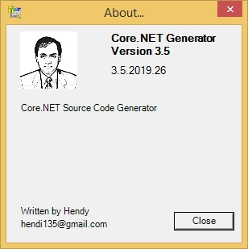

## 2. Connect ke Database

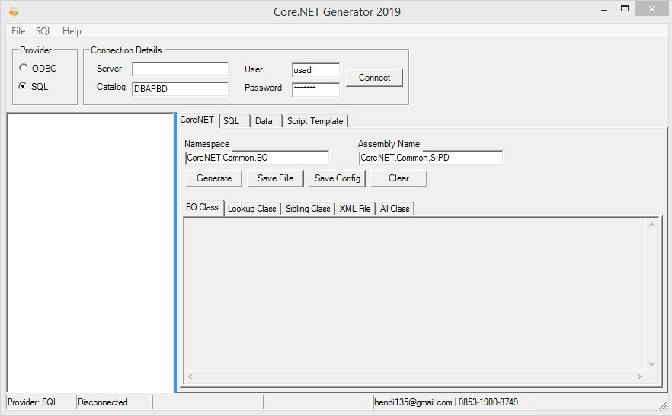

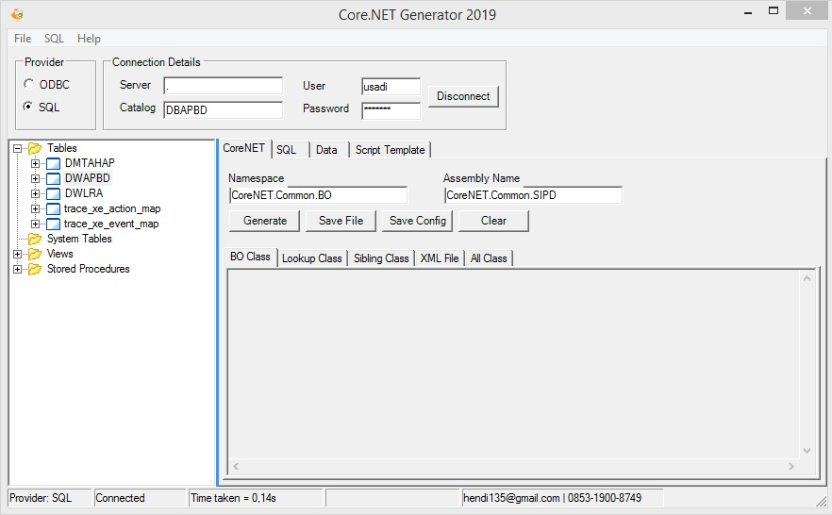

## 3. Generate BO (*Bussiness Object*) *Class* File



## 4. Generate *Lookup Class* File

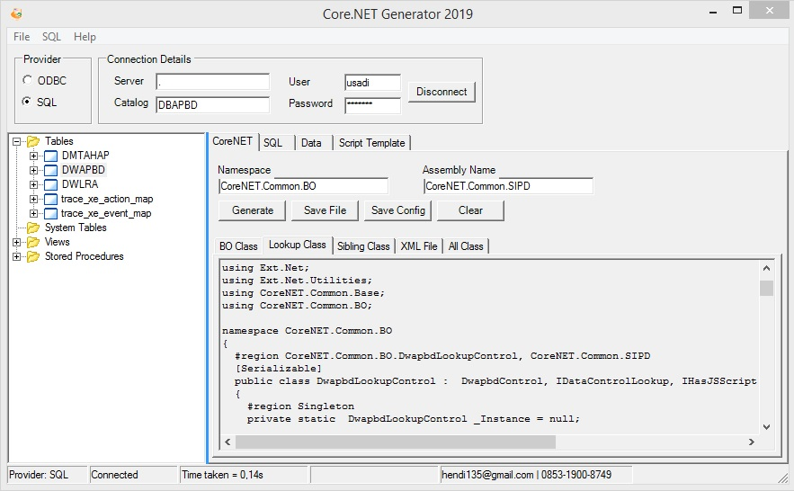

## 5. Generate *Sibling Class* File

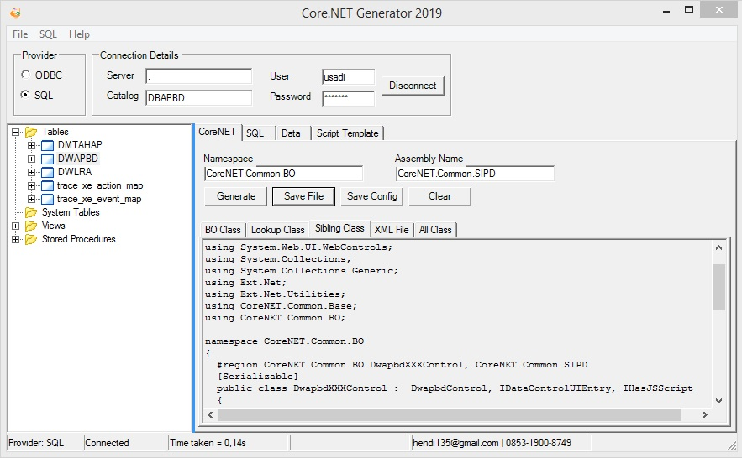

## 6. Generate XML File

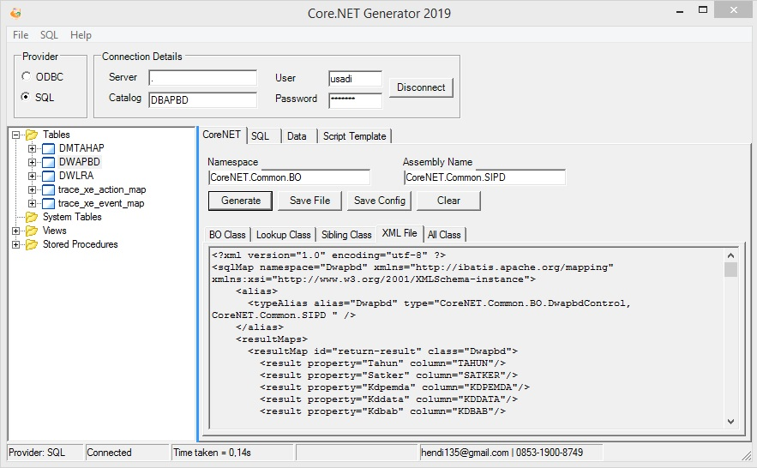

## 7. Generate ConstantTables Entries

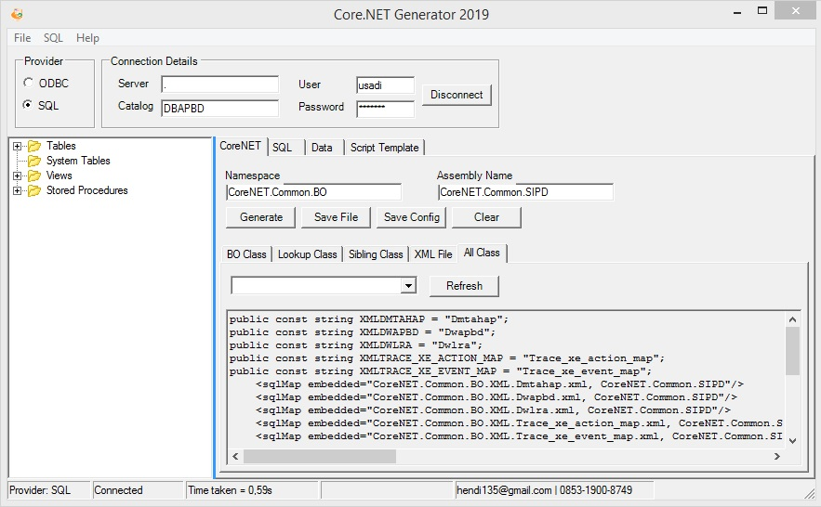

## 8. Generate sqlmap.config Entries

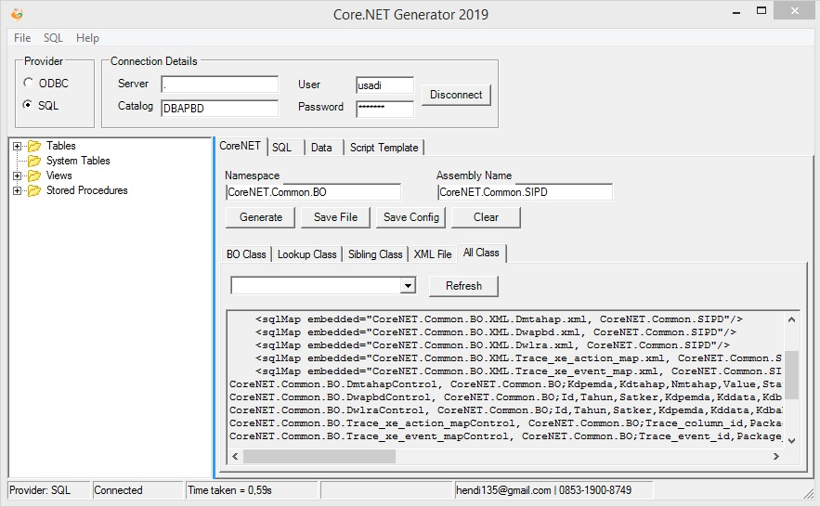

## 9. Generate Properties from Table

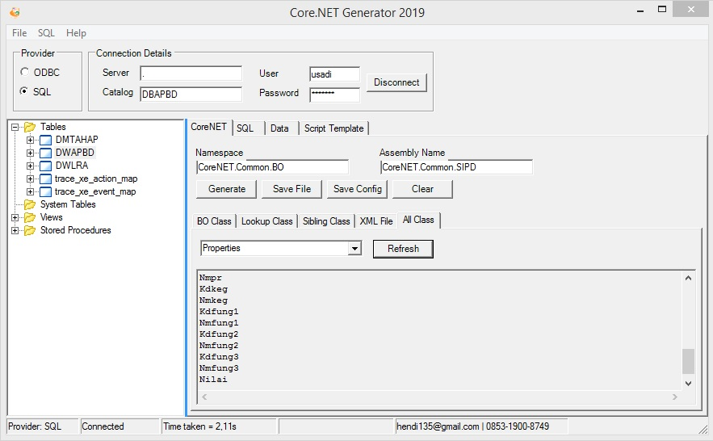

## 10. Generate ConstantTable Class

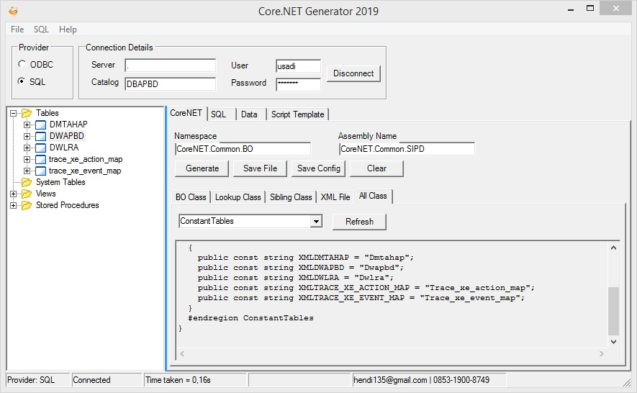

## 11. Generate Snippet Region IdataControlTreeGrid3

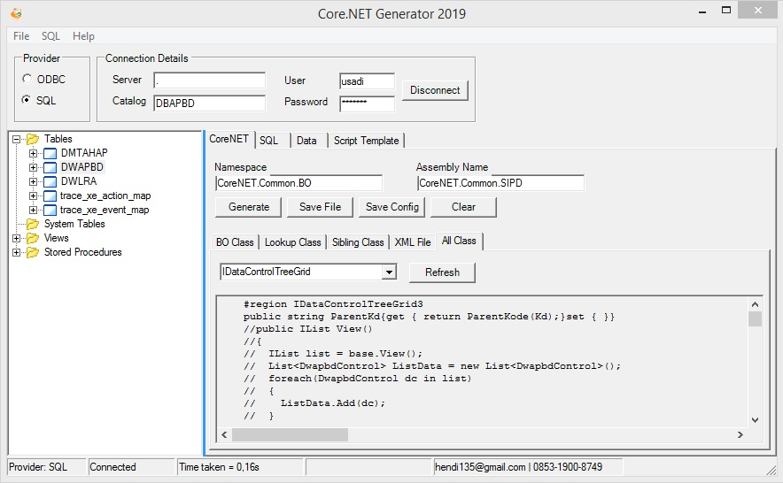

## 12. Generate Entries GetColumn() Method

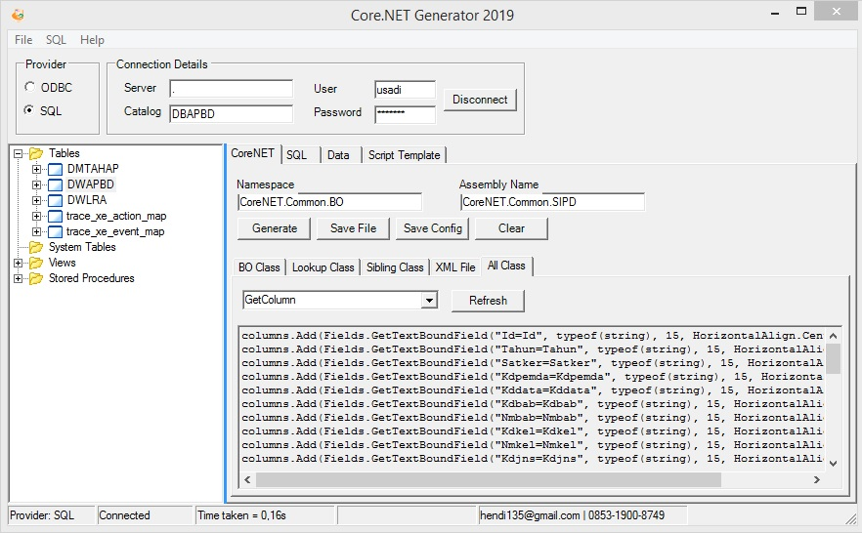

## 13. Generate Entries GetEntries() Method

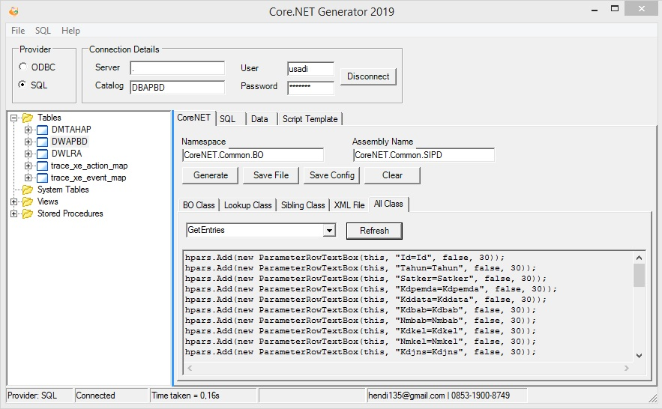

# Lampiran D CoreNETLauncher

## 1. Menampilkan Versi dari “CoreNETLauncher”

### 3.1 Klik menu “**About**” untuk menampilkan jendela “**About**”

### 3.2 Mengetahui versi CoreNETLauncher dari jendela “**About**”

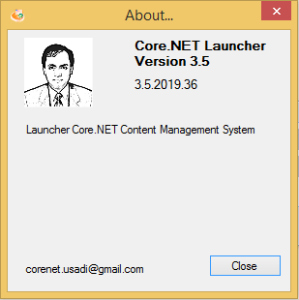

Contoh CoreNET Launcher yang dijalankan versi “**3.5.2019.36**”

## 2. Mode “File Explorer”

### 3.1 Klik menu “**About**” untuk menampilkan jendela “**About**”

### 3.2 Mengetahui versi CoreNETLauncher dari jendela “**About**”

## 3. Update CoreNET WebCMS

### 3.1 Klik menu “**Update CMS**” untuk menampilkan jendela “**Update CoreNET CMS**”



### 2.2 Klik tombol “Update”

### 

### 2.3 Jika berhasil, progress update akan muncul, file-file library terbaru akan didownload dan akan muncul pesan sukses.

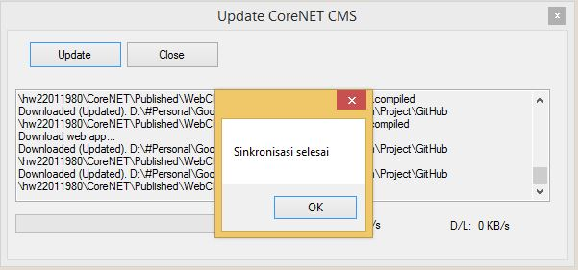

## 3. Troubleshooting

# Lampiran E Instalasi WebCMS di Internet Information Services (IIS)

1. Pastikan IIS terinstal di komputer anda.
2. Pastikan .NET Framework versi 3.5 terinstal di komputer anda
3. Jalankan *tool* **regiis.bat** di folder **/Tool** dari folder **ADK CoreNET Framework** yang sudah anda download
4. Jalankan ***IIS management services*** dengan me-run ***inetmgr*** di *run dialog/command prompt*
5. Klik kanan di “Application Pool” lalu klik “**Add Application Pool**”
6. Klik kanan di “Default Web Sites” lalu klik “**Add Application**”
7. Isikan nama aplikasi dan lokasi (path) dari aplikasi WebCMS, yaitu di :
8. Tes aplikasi dengan cara klik kanan
9. Jika tidak ada pesan error, aplikasi WebCMS telah berhasil diinstal dengan alamat http:// localhost/myapp”
10. Edit file konfigurasi CMSLauuncher
11. Tambahkan URL di langkah 9 ke modul aplikasi

# Lampiran F Data Berstruktur/Berlevel/Berjenjang

1. Data berstruktur/berjenjang/berlevel adalah

# Lampiran G Status dan Status Icon

1. Data berstruktur/berjenjang/berlevel adalah

# Lampiran H Daftar Jenis ParameterRow (Entry di GetEntries)

**GetEntries** adalah *abstract method* dari interface **IDataControlUIEntry**, yang harus diimplementasikan oleh suatu kelas controller yang menggunakannya. Fungsi dari **GetEntries** adalah membentuk “**form entry**”, yaitu halaman berbentuk form/formulir untuk menambah atau mengedit suatu baris data dari suatu tabel database.

Berikut ini jenis komponen UI yang dapat digunakan dalam suatu **form entry**.

|  |  |  |  |
| --- | --- | --- | --- |
| No | Type | Reference Class | Keterangan |
| 1 | Class | ParameterRow |  |
| 2 | Class | ParameterRowAppBy |  |
| 3 | Class | ParameterRowCek |  |
| 4 | Class | ParameterRowCreBy |  |
| 5 | Class | ParameterRowDate |  |
| 6 | Class | ParameterRowForum |  |
| 7 | Class | ParameterRowHelp |  |
| 8 | Class | ParameterRowHtml |  |
| 9 | Class | ParameterRowLastBy |  |
| 10 | Class | ParameterRowLookup2 |  |
| 11 | Class | ParameterRowMemo |  |
| 12 | Class | ParameterRowModBy |  |
| 13 | Class | ParameterRowNumeric |  |
| 14 | Class | ParameterRowProgress |  |
| 15 | Class | ParameterRowRevBy |  |
| 16 | Class | ParameterRowSelect |  |
| 17 | Class | ParameterRowSignBy |  |
| 18 | Class | ParameterRowTextBox |  |
| 19 | Class | ParameterRowTextBox2 |  |
| 20 | Class | ParameterRowTime |  |
| 21 | Class | ParameterRowType |  |
| 22 | Class | ParameterRowUploadFile |  |

# Lampiran I Daftar Jenis Kolom Grid (Entry di GetColumn)

1. Data berstruktur/berjenjang/berlevel adalah

|  |  |  |
| --- | --- | --- |
|  |  | Dear Brothers & Sisters  All over the universe  Feeling troublesome when learning programming?  It's no longer a time when you are confused about learning front-end and back-end programming. Start learning **CoreNET Application Development Kit** to create transactional **web-based** or **hybrid desktop** applications.  Contact us for training information.  With Love 3000  Hendi Wibowo |
| Hendi Wibowo  CoreNET Framework Evangelist  **CONTACT**  PHONE:  (+62)-813-9592-9218  WEBSITE:  <https://www.linkedin.com/in/hendi-wibowo-12938458/>  EMAIL:  hendi135@gmail.com |  |